UNIVERSITY AMERICAN COLLEGE SKOPJE
SELF-EVALUATION REPORT

ACADEMIC YEAR 2020/2021

University Profile

The University American College Skopje (UACS) is an institution for higher education that combines the best of American and European educational experiences. It was founded with the understanding that all people are created equal and enriched by education. Founded in 2005 as one of the few private and independent universities in the Republic of Macedonia.
UACS offers American efficiency through carefully designed curricula that incorporates up to date professional literature and case studies from distinguished authors. UACS considers itself a Third Generation University – University independent from Governmental support, mainly teaching in English and operational in a regional or global market.
It is guided by the 3-I Principles:
· International Faculty;
· International students body;
· International curricula, textbooks and teaching supplements.
The University started as a single school – School of Business Economics and Management (SBEM) in 2005. Later on, in 2006 it has grown into a University offering majors in: Architecture, Software Engineering, English language; Political science. In 2008 the Law School was added, and in 2016 International School of Architecture and Design offering degree in Turkish language.
School of Business Economics and Management (SBEM) was founded in 2005 and offers undergraduate, graduate and doctoral studies. Undergraduate studies are with duration of 3 years, during which the student acquires, a minimum of 180 ECTS and a degree title in the specified field.
The excepting is the concentration Audit and Accounting, being offered as a four, 240 ECTS program.
The Graduate studies offer the possibility of acquiring the title Specialist or Master in the specified academic field. The specialization studies last 1 year and the student obtains 240 ECTS, which is equivalent to U.S. Bachelor. The Master's degree lasts for 2 years, and the student obtains 300 ECTS.
The Doctoral studies are with duration of 3 years, during which the student obtains 180 ECTS. The programs for undergraduate and graduate levels are designed to be completed in 3+1+1 years, with the full option of transferring credits from other accredited institutions.

- Table 1 – UACS undergraduate, graduate and doctoral school programs

Table 1.1 Number and types of study programs at undergraduate level (first cycle)

School | Number of study programs | Study programs
School of Business Economics and Management | 6 | - Management  - Marketing  - Finance  - Audit & Accounting  - Human Resources  - Double degree program with Tor Vergata, University of Rome

Table 1.2 Number and types of study programs of Graduate studies (second cycle)

School | Number of study programs | Study programs
School of Business Economics and Management | 6 | - Management  - Marketing  - Finance  - Audit & Accounting  - Human Resources  - Business administration and Economics

Table 1.3 Number and types of study programs of Doctoral studies (third cycle)

School | Number of study programs | Study programs
School of Business Economics and Management | 2 | - PhD in Economics  - Doctor of Business Administration (DBA)
School of Law | 1 | - Doctor in Law

The number of students in each academic unit.
Below in Table 2, one can see a list of the number of students at each academic unit for the academic year 2020-2021
School | Undergraduate Program | Graduate  Program | Doctoral  Program | TOTAL
School of Business Economics and Management | 311 | 97 | 32 | 440
School of Architecture and Design | 168 | 30 | / | 198
International School for Architecture and Design | 5 | / | / | 5
School of Political Science | 79 | 4 | / | 83
School of Computer Science and Information Technologies | 164 | 7 | / | 171
School of Foreign Languages | 28 | 12 | / | 40
School of Law | 32 | 13 | 3 | 48
TOTAL | 787 | 163 | 35 | 985

Table 2 - Number of students

University Accreditations
The University American College Skopje (UACS) is accredited by the Board of Accreditation for Higher Education and licensed by the Ministry for Education and Science of the Republic of Macedonia. It is licensed to offer undergraduate, graduate and doctoral level degrees by the Ministry of Education and Science.
ACBSP (American Council for Business Schools and Programs) is the leading organization for accreditation of business education. It granted accreditation to the business programs at UACS, which confirms that the educational process in the business-related programs at UACS meets the rigorous standards of this organization.
UACS holds ACCA accreditation for Accounting and Audit program. The ACCA (Association of Chartered Certified Accountants) is a globally acclaimed body that offers international certification for accountants and auditors, by passing a customized exam divided into 12 modules. UACS, has incorporated 8 of those modules in their academic program for accounting and audit, so that once students complete their academic program, they will only have to take 4 more exams to obtain ACCA certification.
UACS is currently the only higher education institution in the region that has implemented the exams into their programs and has made it available for students that wish to pursue some of the most highly paid careers in the world.
The Turkish Council of Higher Education (Y.O.K.) awarded full recognition of all programs offered by the University. The scope of recognition covers (undergraduate and graduate) academic programs. YOK is a non-governmental body that oversees universities in the Republic of Turkey as well as students who study abroad at schools and universities approved by the agency. The Council for Higher Education YOK regulates universities and aims at improving the quality of higher education.

Decisions for accreditation
- Decision for the commencement of the delivery of first cycle programs - 3 year academic studies at UACS
- Decision for the commencement of the delivery of second cycle study programs - one-year Specialization and two-year Master studies at UACS
- Decision for accreditation of first and second cycle study programs at the School of Business Economics and Management

International Cooperation Agreements
SBEM Partnership Universities
CONTRACS WITH UNIVERSITIES RANKED TOP 500 ACCORDING TO ARWU  - University Tor Vergata, Rome, Italy  Dauphine University, Paris (www.dauphine.fr) Technical Faculty of Bor, University of Belgrade  - Technical University Vienna https://www.tuwien.ac.at/en/  Eötvös Loránd University, Budapest  OTHER INTERNATIONAL COOPERATION AGREEMENTS  - Maastricht School of Management, Maastricht ,Netherlands (http://www.msm.nl/)  - Aachen University of Applied Sciences, Aachen , Germany  - International University of Monaco, Monaco (www.monaco.edu)  - Virginia International University, Fairfax USA (www.viu.edu)  - John Cabot University, Rome (www.johncabot.edu)  - Vesalius College Brussels (www.vesalius.edu)  - Horizons University, Paris (www.horizonsuniversity.org)  - CMH Academy and IEMI- European Institute of International Management, Paris  - East Carolina University, USA (www.ecu.edu)  - Institut Supérieur de Gestion (ISG), Paris (www.isg.fr)  - Swiss Management Center, Zurich, Vienna (www.swissmc.ch)  - European Institut of Education,San Gwan, Malta (www.eieonline.com/)  - St.Louis Community College,Missouri (www.stlcc.edu/)  - http://www.fh-aachen.de/en/  - University of Applied Sciences Baltazar Zaprešić, Croatia , http://www.vspu.hr  - Caucasus Univeristy from Georgia, Georgia, http://www.cu.edu.ge/en  - EDEM Escuela de Empresarios, Valencia, Spain http://www.edem.es/Inicio.aspx  - Miguel Hernández University of Elche, Valencia, Spain http://en.umh.es/  - ESIC-Business and Marketing School, Malaga, Spain http://www.esic.edu/malaga/  - Gazi University, Ankara, Turkey http://gazi.edu.tr/  - GEA College , Ljubljana, Slovenia http://www.gea-college.si/  - Lazarski University, Warszawa, Poland, http://www.lazarski.pl/en/international-exchange/contact/  - Politehnica University of Timisoara, Timisoara, Romania http://www.upt.ro/english/ |  | - Romanian American University, Bucuresti, Romania http://www.rau.ro/index.php?newlang=english  - Varna University of Management , Bulgaria , http://vum.bg/  - Universidad a distancia de Madrid, Madrid, Spain http://www.udima.es/  - VSEM College of Economics and Management, Prague (www.vsem.cz)  - Baku Business University from Baku, Azerbaijan, http://bbu.edu.az/en  - Mehmet Akif Ersoy University , Turkey, http://mehmetakif.edu.tr/  - Univesidad de Burgos , Spain http://wwww.ubu.es/  - Friedrich Schiller University Jena , Germany , http://www.uni-jena.de/  - Haute Ecole de la Province de Liège , Belgium http://www.provincedeliege.be/  - Université Catholique de Lille, France , http://www.fges.fr/  - UNICUSANO , Italy, http://www.unicusano.it/en/  - University of National and World Economy ,Sofia, Bulgaria http://www.unwe.bg/en/  - University of Applied Sciences Worms, Worms, Germany http://www.hs-worms.de/  - Universita di Foggia, Foggia, Italy http://www.unifg.it/  - Muğla Sıtkı Koçman University, Mugla,Turkey http://www.mu.edu.tr/  - University of Pila, Pila, Poland, http://www.mu.edu.tr/  - Angel Knachev University of Ruse, Ruse , Bulgaria https://www.uni-ruse.bg/en/univers

The Student Affairs Office i.e. Records Office is organized in a way that it meets the needs of prospective and current students in terms of educational development in higher education. For easier coordination, the office is divided in three departments:
- Department for undergraduate studies,
- Department for graduate studies, and
- Department for doctoral studies.

The coordinators within each department are as follows:
Coordinator | School of Business Economics and Management
- Iva Gjorgjieva is coordinator of the undergraduate students | - The School of Business Economics and Management, from 1 to 3 year of study (undergraduate level)
- Nadezda Pop-Kostova is coordinator for the graduate studies. | - The School of Business Economics and Management- MBA Program - 4 and 5 year  - The School of Business Economics and Management-MA program - 4 and 5 year
3. Elena Popovska is coordinator for undergraduate  studies and doctoral studies. | - Doctor of Business Administration (DBA)  - PhD in Economics  - The School of Law  - The School of Political Science and Psychology  - The School of Computer Science and Information Technology  - The School of Foreign Languages
- Elena Penkova is coordinator for undergraduate studies. | - The School of Architecture and Design  - The School of Business Economics and Management
- Sonja Filipovska is coordinator for issuing final documents (diploma and transcripts) | - The School of Business Economics and Management  - The School of Architecture and Design  - The School of Computer Science and Information Technology  - The School of Law  - The School of Political Science and Psychology  - The School of Foreign Language

The Records Office provides support to students in terms of:
- Course Enrollment
- Advising on electives;
- Info about courses, results, consultations.

PART I – Leadership

School of Business Economics and Management
Criterion 1.1
The leader of the school unit is to be accountable for the development, execution and continuous improvement of the programs and processes in the school unit, and for their compliance with the ACBSP Standards and Criteria.The Dean, in such instance, acts as a gateway of communication between the management and the faculty, between the strategic directions set forth by the university as a whole and the programmatic improvements needed for the school, as well as over viewing regular day to day operations.
Regular activities of the Dean that encompass actions that promote the development, execution and improvement of the processes of the school and academic programs are listed below in Table 1.1.

Table 1.1 Dean’s activities
Activity | Description | Number of activities held in 2020/2021 | Parties included | Key Activities and Outcomes Reported in
Faculty Council Meetings | The Deans assemble Faculty meetings to discuss current and upcoming activities:  Schedule  Elections of faculty  Discussion of evaluations;  Discussion of other relevant documents. | 2020: 8 meetings  2021:9 meetings | - Dean of the School,  - Faculty members,  - Administrative staff | Faculty Council Meeting Minutes are made available to all relevant parties
Departments Meetings and Reports | The Heads of Departments assemble meetings to discuss the program, students’ satisfaction and issues. | Two meetings per year/ once in a semester | - Head of Department  - Professors who are part of the department | Department meetings are made available to all relevant parties
Quality Circles Meetings  Meetings with students from each academic year and study concentration, where they meet with up with the Dean and discuss all aspects of their experience with the program and give their viewpoints and suggestions. | - Quality of:  - teaching process  - administrative staff  - library and books  - Cafeteria  - IT | Two sessions per year / once in a semester | -Students  -Faculty | Act upon the student suggestions where possible within the academic year and conduct graduate level quality circles meeting
Career Development Workshop | The career development workshop is dedicated to teaching the students regarding their future job, ways to find job, writing CV and have a catch-up with the most influential recruiters in the country. | Once per year | - Dean of the School,  - Faculty members  - Career Center department  - Influential recruiters in the country  - Students | Excellent opportunity for recruitment students for internships
Meet up hours | Advising students on academic probation |  | - Dean of the School  - Faculty members  - Administrative staff  - Students
Master thesis seminar | Supporting students during the process of writing master thesis | Twice a year | - Dean of the School  - Faculty members  - Administrative staff  - Students | Students were taught regarding the whole process of writing master thesis. They had a chance to speak with their potential mentors, discuss the topic of interest and receive guidelines of how to write dissertation from scratch.

Criterion 1.1.a.
Administrators and the faculty must set, communicate, programs values and performance expectations.
Primarily, the program values and expectations are set within the University’s Mission, Vision and Value statements. The communication and enforcement of program values and performance expectation is consistent throughout the academic year. It is primarily effectuated through the Faculty Council Meetings for each School, but also through a variety of other activities. Some of them are aimed at internal strengthening of the program values and expectation, and others at communicating the same values and expectations to various stakeholders.

A summary can be found in table 1.1.a below.
Activity | Description | Number of activities held in 2020-2021 | Parties included | Key Activities and Outcomes Reported | Specific activities relevant to criterion
Orientation Day | Introducing students to the staff, bylaws and procedures and overall experience of the university campus. | 1 | New Students  Administrative staff, faculty, deans | / | - Introduction to the premises  - Introduction to faculty and general information on the program  - Description of student rights and obligations  - Information on university code  - Introducing the students to campus life and setting expectations for their progress
Teaching Improvement Seminar (Padlet Workshop) | Discussion with the faculty members regarding the ways of teaching | 1 | - Faculty members |  | -Sharing teaching experience  -Suggestions on new ways of teaching
Career days at UACS  Part I (students divided into groups, workshop for writing biography)  Part II (lectures from Human Resource managers from the Industry)  Part III (networking with company’s who offer internships) | Excellent opportunity for recruitment students for internships | 1 | - Head of Career Center and Dean of SBEM | / | The main topics for each meeting was:  - finding internship opportunity of student’s interest,  - developing professional CV,  - advising and preparing students for the first interview  - assisting and helping students for applying in international institutions,  - encouraging students to enroll in different companies each year in order to gain more experience and to brand their CV

Criterion 1.1.b.
Programs must have processes in place for evaluating the performance of both administrators and the faculty. Explain how the performances of administrators and the faculty are evaluated.
UACS has adopted a policy for 360 degrees evaluation. This policy has been adopted since 2011. In meantime it has undergone various revisions. We’re still searching for the best model. However in 2018/2019 we have performed the 360. More details have been presented in Chapter V.
Criterion 1.2.
Programs should address the impacts on society of its program offerings, services, and operations.
Table 1.2.b.
 |  | Description | Measure/Activity
Business Council |  | Contacts with the business community keep the programs up to date and hence allow contribution to the development of companies (through proving them quality new employees) | Discussions with BC members
Corporate Responsibility |  | SBEM regularly organize at least one event per year that addresses some societal/global issue together with the students | Series of donations organized by Venera Krliu Handjiski, wishing to help our country a better place.
Round tables and workshops |  | We provide research on a topic that is very critical for the country, raise the public awareness on the topic and propose some policy recommendations | - Workshop –for PhD Students (Organized by prof. Marjan Petreski, PhD)
International Conference |  | The annual international conference is held each year.  This year, the date month of the conference was changed. Instead of spring, the organizational committee decided that from this year on, the conference will take place in September. | The conference involved about Macedonian and International scholars, and it was organized in a virtual manner due to Covid-19 situation.  For more info, please check the official website: http://www.aicei.uacs.edu.mk

PART II – Strategic Planning & Annual Planning

Criterion 2.1. The business unit must have a formal process by which its strategic direction is determined, its action plans are formulated and deployed, and innovation and creativity are encouraged. Describe your formal process for strategic planning.
UACS has adopted a complex and inclusive process of strategic planning.
So far, we have had three cycles: 2005-2010, 2010-2015, and 2016-2019. In 2016, we decided to shorten the cycle due to the high volatility of the external environment.
In 2019, we adopted a 3-year plan, but it collapsed on March 10th 2020 with the Corona outbreak.
The process is in three stages:
- The first draft comes out of the Provost Office;
- There was a discussion at the Rector’s Board meetings, Board of Directors and Strategic Planning and/or Team Building sessions;
- Finally, the plan was adopted by the Board of Directors.
On November 7th, 2019, the Strategic plan was presented to the Rector’s Board on its 11th session, and it was adopted a month later, on December 19th, 2019, during the 12th Rector’s Board session. SBEM adopts Annual plan under the guidance from the Strategic plan.
The Strategic plan started with a draft developed by the UACS Provost, and it was presented to the Board of Directors. The final version was approved and adopted by the Board of Directors on its 6th session, held on December 24th, 2019.
STRATEGIC PLAN 2020-2023 (content)
t.1 Report on the Strategic plan 2016-2019
t.2 Situational Analysis
t.3 Strategies and Policies - General Strategies
t.4 Long-term goals
t.5 Academic and Accreditation goals
t.6 HR goals and strategies
t.7 Internationalization
t.8 Marketing and Sales
t.9 Digitalization
t.10 Research and Library
t.11 Networking
t.12 Finance

The same goes for the SBEM’s Annual plan. It follows a formal, three-step procedure:
1. Draft by the Dean
2. Initial discussion (on the 07th session, on June 09th 2019)
3. Final adoption (on the 08th session, on September 27th 2019).

Emergency Planning and Actions – COVID-19
Due to the COVID-19 pandemic, in 2020, UACS engaged in emergency planning, but we still managed to keep the spirit of the participative management by organizing several meetings:
- March 10th - Rector’s Board - Cancel operations temporarily;
- March 16th - Rector’s Board and University Senate session, organized as a Town Hall Meeting with all faculty and staff;
- March 16th - Rector’s Board meeting with all faculty members invited - Presentation of Bylaws on conducting UACS Hybrid;
- March 16th - University Senate adopts the Decision on organizing Hybrid teaching at UACS;
- March 16th - University Senate adopts the Decision on organizing the Mid-term examination on Moodle;
- March 30th - University Senate adopts the Procedure for online lectures and online examination at UACS;
- June 29th - The University Senate adopted the Bylaw on Hybrid teaching at UACS in the academic year 2020/2021, which was previously approved by the Rector’s Board;
- August 26th - Convocation Day (The first Hybrid).

Criterion 2.1.a. The faculty and staff members of the business unit should have significant input into the strategic planning process. Explain how the faculty and staff members participate and/or have a voice in the strategic planning processes
UACS strategic planning process can be considered as role model of participative decision-making. It includes the voices of faculty and staff.
1. Step 1 - Draft from the Provost
2. Step 2 - Strategic Planning session, discussion by the Rector’s Board (usually, at least two 2 sessions)
3. Adoption by the Board of Directors

For the SP 2020-2023 Strategic Planning session was within the Team Building “Get Involved VII”, which was held in Ohrid, in June 2019. All UACS Schools participated.
This was a good opportunity to include the full-time and adjunct faculty members in the process. Faculty and staff gave many ideas about the future of UACS, most relevant are:

Idea | By | Action | Results
Managing the Alumni Association | Dr. Sasho Ordanoski | Hired Aleksandra S. Klincharova | Good start, but Corona put it on hold
Review of integrated curricula Y1 to Y5 | Committee on programs | To be reviewed for the next reaccreditation

SBEM Annual plans were also discussed and approved by the Faculty council.
As mentioned previously, the annual plan 2019-20 was adopted on September 27th, 2019 (please see the Appendix).

Criterion 2.1.b. The strategic plan should identify the business school’s or program’s key strategic objectives and the timetable for the current planning period.
For the period 2020-2023, we propose the following general strategies:
1. Differentiation and Top-Notch Quality;
2. Internationalization;
3. Third mission (by the community and for the community).

Long-term goals  Stability and Sustainability | Roles | Strategies | KPI
Maintain number of students to 800 | Rector’s Board  Board of Directors | Differentiation | No. of students

HR goal | TimeLine | Key Role | Policies | Resources | KPI
Rejuvenation and meeting HEA 61.3 | 2020-2023 | Provost, Deans, VRR | Prof.  development | Budget for professional development | No per school
Academic &  Accreditation Goals |  | Time Frame | Key Role | KPI
ACBSP Renewal of Accreditation |  | 2020/2021 | Provost, CAO, Dean | Accreditation

Networking Goal | Lead Role | Measure KPI
Organize one PR event per month | Stakeholders  Director | Progress report
Business council – Keep Pace; GAM - once in two years | Networking | Progress report

However, due to the COVID-19 pandemic, UACS has engaged in emergency planning and execution.
It included both building performance capabilities and building legislation, since we had had no regulations for on-line teaching.

Date | Capacity Building | Legislation Building
10 March |  | Decision of Rector’s Board | Break of campus education
13 March | Training, WebEx contract |  | First on-line class
16 March | Training for schools and professors | Rector’s Board decision | To start with on-line classes as of 30 March
16 March | Training how to develop tests | Rector’s Board decision  QCC Decision on the test structure | To develop Moodle tests
March - May, 2020 | Several webinars for using Webex and Moodle
29 June |  | Decision on organizing the academic year 2020/2021 at UACS, which includes 3 options for providing lectures. | It includes 3 options for providing lectures: online lectures, hybrid (combined lectures), and lectures with full physical presence at the University.
29 June |  | Bylaw on organizing hybrid lectures at UACS for the academic year 2020/2021 | It includes general information, physical and health protection equipment, organizing the lectures at the University, technical equipment, academic calendar, distance learning for foreign students, distance teaching for foreign lecturers, organizing lectures for part-time students, internship, organizing the staff and the library, etc.
NOTE: This is just an excerpt. The full list is available in the plan itself.

Criterion 2.2.a. Strategic action plans should address both short-term and long-term objectives.
UACS SBEM or the Business unit also develops annual plans.
They are drafted by the Dean and approved by the Faculty Council. UACS SBEM are action yearly plans. They follow the main directions as set in the Strategic plan.
The last Annual plan was adopted by the Faculty Council, on its 8th session held on September 29th, 2019.
Faculty Council also monitors the implementation.
Here are some goals from the Strategic plan, which are of the short-term nature.
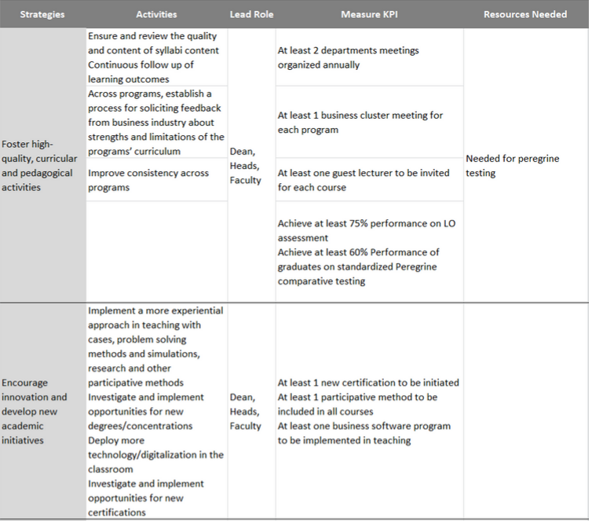

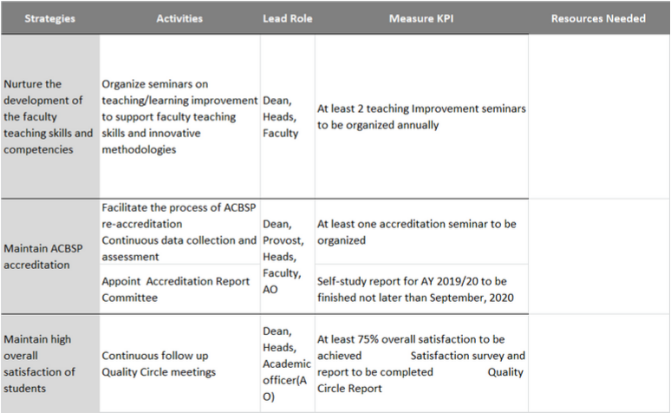

Criterion 2.2.c. The leadership of the business unit should communicate strategic objectives, action plans, and measurements to all faculty, staff, and stakeholders, as appropriate
At the beginning of every academic year, sometimes both at the start and at the end of it, we have a Strategic Planning session.
This is a traditional town hall format meeting with all faculty members and staff.
We had one on September 25th, 2019. The main topics of the meeting were:
· UACS achievements (COST Project, SAD & Municipality of Prilep Erasmus project, papers published by the UACS Provost, etc.)
· After the Team Building Retreat in Ohrid (ideas and realization for the development of the new strategic plan)
· Curriculum, HR & other activities
· New things at UACS (Accreditation for MIS DBA, New computer lab)
· Presentation on current enrollment
· “People come, people go” chapter
· Events and important issues (past events & upcoming events)
The second session, in a different format - as Electronic Town Hall Meeting - was held on March 16th 2020, entitled “The end of the world as we know it”, where the Provost outlined his strategy for going through the COVID-19 pandemics.

PART III – Student & Shareholder Focus
Criterion 3.1
Business programs must determine (or target) the student segments its educational programs will address. State targeted and served student segments.

Table 3.1. Student targeted segments
Educational program | Student Segment Targeted | Rationale
Undergraduate Full -Time program | Domestic high school graduates | The typical target for this program is the typical age high school graduates that are inclined to pursue higher education
Undergraduate Full -Time program | International students | The programs at the SBEM, has been made available in English for foreign & domestic students
Undergraduate Part -Time program | Domestic students | Working professionals wishing to complete their education
Graduate Full – Time program | Graduate students that pursue furthering their education | The typical age college graduate, that seeks to pursue a master’s degree

Criterion 3.2
The business unit will have identified its major stakeholders and found methods to listen and to learn from its stakeholders in order to determine both student and stakeholder requirements and expectations.
List your business unit’s major stakeholders other than your students. Briefly describe how you gather and use relevant information from students and stakeholders.
The university has identified two main groups of stakeholders; primary and secondary.

Primary stakeholders refer to the segment that the school has a direct impact on (or from) i.e. that immediate needs of stakeholders have been addressed and there is sufficient data to provide plausible outcomes.
Secondary stakeholders are not directly impacted by the operations of the school and their needs will be addressed in future planning of the ways to introduce such focus groups and their specific outcomes. Short- and long-term requirements are determined in a variety of ways. The following table shows the stakeholders that have been addressed, and the manner of obtaining relevant information.

The Business School addresses the same stakeholders and their needs as identified at university level.
Primary stakeholders | Secondary stakeholders
- Students  - Faculty and Employed  - Control and Regulatory bodies: (MON, BoA, ACBSP) | - Board of Directors of the University  - Business Council  - Student’s parents  - Alumni

Criterion 3.3
The business unit will periodically review listening and learning methods to keep them current with educational service needs and directions. Describe your periodic review processes pertinent to this criterion.
UACS has established a process for reviewing the methods for gathering data.
Namely, the Self-Evaluation Committee or the CAO together with the Stakeholder Relations Officer reviews:
- The data collected from the surveys – Once every year as the surveys are completed
- The response rates and method of administering the surveys – Once every year as the surveys are completed
- The questionnaire themselves – Once before the beginning of the academic year
Some of the data is also gathered through meeting minutes and face-to-face communication with the stakeholders, and is also taken into consideration.
The CAO and Stakeholder relations officer makes suggestions for improvement of the methods of gathering the information and presents it at Faculty Meetings and the University Senate. Each Schools reviews the data and the results and make suggestions for improvement.

Criterion 3.4
The business unit will have a process to use the information obtained from students and stakeholders for purposes of planning educational programs, offerings, and services; marketing; process improvements; and the development of other services. Describe your processes pertinent to this criterion.
The School uses relevant data to assess whether there is a need for improvement in the educational program offerings. These considerations are discussed initially internally on the Faculty Council Meetings.
Any suggestion for improvement is then referred to in the Annual Action Plan for the School.
The improvement suggestions are also conveyed to the University Senate and Rectors Board so that any major changes and/or addendums are revised to be in line with the strategic goals of the University. If there is a fit between the current availability of resources and the improvement measure, then it is implemented and addressed. The following table shows some of improvements that have been made during the course of the academic year

Stakeholder | Information/Requirement | Information Obtained via | Reviewed by | Educational Program addressing requirement
Alumni | Reconnecting and networking between the alumni network | Free executive training | Alumni (Graduate 10 years ago / Graduate 1-5 years ago)  Students | Introducing the businesses and employment opportunities between members
Alumni | Networking and speed dating among alumni members. Lecturing on specific subject, sharing knowledge and experience. | Training and Networking | Alumni (Graduate 10 years ago / Graduate 1-5 years ago)  Students | UACS welcomed lecturers from business practice
Alumni | Lecturing on specific subject, sharing knowledge and experience. Inspiring stories of the alumni speakers. | Alumni guest speaks for undergraduate and graduate students | Undergraduate students | Each semester UACS invite a guest lecturer from the Alumni members.
Alumni | Assessing success after graduation | Survey via phone calls | Head of Career Center Development | Alumni survey used to assess success after graduation.
Students | Providing internship opportunities in Alumni’s company’s | Careers days, daily communication via e mail, info boards and in person in the career center office | Head of Career Center  Companies where Alumni work,  Companies that Alumni own | Career center provides internship opportunities via communication with the HR offices in the company’s, developing project with the companies for the need of internship experience to the students.
Students | Providing internship opportunities in Business council members company’s/organizations/ NGO’s | - Daily and weekly communication via e mail, info boards  -Career days  -Individual sessions with the Head of Career Center department | Head of Career Center  Business council members company’s/organizations/ NGO’s | Career center provides internship opportunities via communication with the HR offices, owners in the company’s, developing project with the companies for the need of internship experience to the students.
Students | Internship opportunities at Governmental bodies (ex. Ministry of foreign Affairs and Embassies) | -Career Center and Governmental bodies | Head of Career Center department  Governmental bodies (Ministry of foreign Affairs and Embassies) | Providing new internship opportunities on domestic and international level
Students | More international experience and exposure | Quality Circles Meetings | SEC, Faculty Council | Reviewing current Erasmus + partner universities and exploring new options
Students | More international experience and exposure | Quality Circles Meetings | SEC, Faculty Council | Introducing the AIESEC Internship program
Business Council | Introduction of more specialized programs that address specific job requirements, such as accounting, auditing etc. | Business Council Meeting | Career Center department, SEC, Stakeholder Officer, Faculty Council | Communication and discussion regarding the course programs and market needs

Criterion 3.5
The business unit should have processes to attract and retain students, and to build relationships with desired stakeholders. Define and describe your processes pertinent to this criterion.
The school actively keeps up with attracting new students to its programs via clear communication with the Networking and Marketing Department. All activities undertaken by the school are aimed at attracting, retaining or engaging both students and relevant stakeholders. They are also communicated to the relevant stakeholders through the Networking and Marketing Department via print or electronic media.

Table 3.5.1. Student attraction processes
Target audience | Activity | Purpose
High School Students | Road show in high schools in and outside of Skopje | Getting high school students acquainted with the academic programs
High School Students | Offering state – matriculation preparatory courses | Aid potential high school graduates with better knowledge for passing the state examination.
High School Students | Scholarship contests | Attracting the best pool of candidates for the scholarships available at the School
High School Students Parents  (Broad audience – General Public) | Active radio, TV, print and social media advertising | Communicate new offerings, attracting new students and reinforcing good practices among current students and other stakeholders, image building
High School Students | Lectures by UACS Faculty | Demonstrating a UACS class in the High schools facilities
High School Students  Working professional  Graduated Students | Open Day | Introducing the University and its programs to interested parties
Working Professionals | B2B meetings | Promotion of the UG & G programs and Executive Educational courses

Regarding student retention, UACS has established several policies to foster the retention process. Some of those processes are also aimed at engaging other stakeholders to support student retention.

Table 3.5.2. Student retention processes
Target audience | Activity | Purpose
Current Students | Student Metrics | Discussed at least once a year, including the indicators on student’s retention and progression
Current Students | Quality Circles | Includes selected students meeting the dean at least twice a semester and discussing options for improvement.
Current Students | Focus Groups | Selected student group meeting the Rector at least once a semester to discuss QC remarks for every school and other broad topics
Current Students | Tutoring Club | Help students with potential difficulties in covering a certain area or course
Current Students | Provide Erasmus and AIESEC Internships | International Exposure
Current Students | Provide Summer Schools and workshops | International Exposure
Current Students | Business council members as guest lecturers | Involving the BC members into the academic program and exposing students to expertise from a specific company/industry
Current Students | Alumni guest lectures | Involving the Alumni community into the academic program and exposing students to expertise from a specific company/industry
Current Students | Career Counseling | To prepare the students for future employment
Current Students | Graduate program benefits presentation for UACS Undergraduates | Retention and progression of UG’s into the graduate programs

The table below, highlights institutional departments and functions that efficiently and effectively work with the SBEM, to admit and retain students in addition to stakeholder support.

Institution Department | Student / Stakeholder Primary Focus | Information, data reporting to SBEM | Activities in support of SBEM strategic plan goals SBEM | Department Scheduled Meetings
Records office | Student admission, student retention | Student enrolment matrix report | Road show in high schools in and outside of Skopje, offering state – matriculation preparatory courses, Scholarship contests, Active radio, TV, print and social media advertising, Lectures by UACS Faculty, Open Day, B2B meetings, Promo Day – Promo Class | During the whole years regarding the communication and marketing action plan
Career Services | Student job and internship opportunities | Searching and informing the students for new internships, part time and full time jobs | Career Days Seminar on how to be successful candidate for job position | Seminars and individual meetings with students
Marketing, communication and networking | Student prospects, stakeholders | Web and social media activities, events, | Campaign events, ads and delivering strategic goals | Semiannual planning, monthly review of the outreach
Alumni services | Graduates | Graduate contact information | Events, e mail outreach for announcing new graduate programs  E mail outreach announcing job opportunities from Business Council members | Semiannual planning meetings
Provost Office | Stakeholders | Invitations to attend events, meetings with stakeholders - Invitations to trustee, board meetings | Invitations to present University strategy at trustee meetings | Annual 2 times

Table 3.5.3. Relationship strengthening with other stakeholders

Target audience | Activity | Purpose
Faculty | Professional Development Opportunities | To enhance teaching quality, motivate faculty, and strengthen bond with the school
Business Council Members | Executive Education Courses offered | To give back to the Business Council members
Business Council Members | Recommending the best students from the years for future employment | Strengthening Business Council Members bonds and providing employment opportunity for the students
Alumni | Alumni Networking | Strengthening alumni bonds and networking
Student’s Parents | Records office is sending grades report to house address | Strengthening bonds with students’ parents
Criterion 3.6
The business unit should have a process to seek information, pursue common purposes, and receive complaints from students and stakeholders. Describe processes pertinent to this criterion.
In terms of addressing the student needs, the school has established a Grievances procedure that formalizes the process of receiving complaints. The Grievance officer is the intermediary throughout the whole process and seeks an amicable solution to each issue. Another form of addressing student concerns is through the regular Quality Circles Meetings, where they can express their opinions on any issue freely.
In terms of other stakeholders their expectations and complaints are addressed either through the organized meetings between the stakeholders or by analyzing the data gathered through systematic surveys.

Table 3.6.1. Formal and informal grievance procedures by students
 | Number of Informal Complaints /Suggestions | Complaints /Suggestions on services | Complaints /Suggestions on faculty | Complaints /Suggestions on administrative staff | Complaints /Suggestions on course/program | Other | Resolved issues
2020/2021 | 5 |  |  |  | ✓ |  | 5

Criterion 3.7:
The business unit should present graphs or tables of assessment results pertinent to this standard.
In order to address this criterion the following tables and graphs has been provided:
- Graph 3.8.1.a. – Undergraduate Student Satisfaction from Course and Professor

- Graph 3.8.1.b. – Undergraduate Student Satisfaction from Services & Facilities

- Table 3.8.1.c. – Undergraduate Student Placement (Employment and Educational Status of Graduates
Academic year |  | Number of respondents |  | Full-Time Employment | Part-Time Employment | Pursuing Further Education | Still Seeking Employment
Cohorts by Major | Number in Class | Number | % | Number (%) | % | Number (%) | %
SBEM  2012-2013 | 12 | 76 | 74.5% | 48(63.1%) | / | 39(51.3%) | 8 (10.5%)
SBEM  2013 - 2014 | 110 | 89 | 80.1% | 53 (59.5%) | / | 54 (60.6%) | 7 (7.9%)
SBEM  2014 - 2015 | 125 | 71 | 56.8% | 35(49.2%) | / | 42(59.1%) | 6(8.5%)
SBEM  2015 - 2016 | 66 | 46 | 69.7% | 33(71.7%) | / | 28(60.9%) | 7(15.2)
SBEM  2016 - 2017 | 54 | 41 | 75.9% | 23(56%) | / | 22 (53.6%) | 9 (21.9%)
SBEM  2017-2018 | 68 | 46 | 67.6% | 31(67.4%) | / | 24 (52.2%) | 6(13%)
KPI | / |  | Not to fall below 60% | Not to fall below 50% |  | Not to fall below 50% | Not to go above 15%

- Table 3.8.1.d. – Undergraduate Student Advising (Career counseling, Academic counseling, Tutoring and Probation)
Academic Year | CV and Cover Letter  % of students participated | Measurement  By timely internships | Interview and Job searching strategies | Measured by  employed  after graduation | Probation | Measured by out of probation | Academic counseling  students received interpersonal advising | Measured by  continued to graduate studies | Tutoring
2012-2013 | 33.7% | 93% | 67% | 50.2% | 92 | 46 (50%) | 80% of | 60.2% | Creation of Tutoring club
2013-2014 | 44.6% | 90.6% | 69.3% | 54.7% | 77 | 60 (77.9%) | 90% of | 61.1% | 6 tutors, 69 hours of tutoring provided
2014-2015 | 43% | 95% | 67.3% | 44.8% | 77 | 60 (77.9%) | 88% | 51% | 5 tutors provided (60 hours)
2015-2016 | ? | 96% | ? | 47.5 % | * | * | * | * | 10 tutors
2016-  2017 | 81 % | 91.6% | 81 % | 77.5% | * |  |  | 58.8% | 6 tutors
2017-2018 | 87% | 94% | 87% | 70% |  |  |  | 60% | 9 tutors provided (388 hours)
KPI | Above 50% | Above 90% on time internships | Above 70% | Above 50% | Decrease no. of probation | Increase student out of probation | Above 80% | Above 50% | Increase tutors and hours by 50%

Note: With a decision by the UACS, due to COVID-19, students are not obliged to have internships. Therefore, no further information regarding the internship was evidenced.

- Graph 3.8.2.a. – Graduate Student Satisfaction from Course and Professor

PART IV – Measurement Analysis of Student Learning & Performance

Criterion 4.1.
The business unit shall have a learning outcomes assessment program.
State the learning objectives for each program (MBA, Ph.D., BBA, AA, etc.) to be accredited. A program is defined as follows: a plan of study is considered a program when it requires a minimum of 12 credit hours of coursework beyond the CPC and/or is recorded on a student’s transcript

The learning objectives assessment program is defined within the following Decisions of SBEM:
- SBEM Decision for assessment of Learning objectives - first cycle of studies
- SBEM Decision for assessment of Learning objectives - second cycle of studies

Describe your learning outcomes assessment process for each program;
The learning outcomes assessment program is defined within the following Decisions of SBEM:
1. Decision for assessment of Intended Learning Outcomes (ILO) on undergraduate study programs of SBEM - No. 14- 1465/6 from 1.09.2014
2. Decision for assessment of intended learning outcomes for second cycle of studies at the SBEM
3. Decision for assessment of ILO for master programs of SBEM are developed and are currently in procedure for acceptance from the School Council and the University Senate.

The process for assessment of the learning outcomes of SBEM undergraduate program is performed in accordance with the
Decision for Assessment of Intended Learning Outcomes (ILO) for the MBA Program from January 2015.

The decision for undergraduate covers combination of methods, including formative and summative, internal and external. The internal formative is including pre-test and post-test assessment аt the beginning and end of the academic year.
- Internal summative are including capstone project assessment including various items from different departments.
- External summative are including external test approved by the Business community and external assessment on students’ internships.

The decision for MBA ILO assessment covers Internal Formative through assignments of different courses. Internal Summative is the evaluation of the Master thesis and External Summative is involving external member as professor of management practice for evaluation of the Master thesis.

Identify external learning outcomes assessment information and data you gather and analyze; and
External learning outcomes assessment is performed on several levels. Summative assessment for undergraduate is performed through implementation of Exit tests, approved from the business council members at the last year of studies. Also at the undergraduate level performed is internship evaluation.
On MBA level external assessment of the MBA ILO is performed through external members in the master thesis’ committee or just external member – professor of management practice written opinion.

Identify formative and summative learning outcome assessment information and data you gather and analyze.
Formative learning outcomes assessment information are the pretest and posttest examination in specific courses, but also formative assessment could be taken the external assessment of the students internships as presented in figure 4.1.
Summative learning outcome assessment information are the capstone project assessment for each program concentration as an internal way of assessment. Another summative form is the exit test at the end of the program.

Assessment tools/data for Undergraduate programs
SBEM Undergraduate program
Concentration | Internal Data and Information |  | External Data and Information
 | SUMMATIVE Data and Information | FORMATIVE Data and Information
Marketing concentration | - Capstone project for concentration LO  - Capstone project for general LO and soft skills | Pre-Post test results (courses)  - Microeconomics  - Business mathematics  - Contract Law  - Introduction to Marketing  - Financial markets and institutions  - International management | - Exit test  - External assessment on students internship
Management concentration | - Capstone project for concentration LO  - Capstone project for general LO and soft skills |  | - Exit test  - External assessment on students internship
Finance concentration | - Capstone project for concentration LO  - Capstone project for general LO and soft skills |  | - Exit test  - External assessment on students internship  External evaluation on final course project

Assessment tools/data for Graduate programs
SBEM Graduate program
Concentration | Internal Data and Information |  | External Data and Information
 | SUMMATIVE Data and Information | FORMATIVE Data and Information
Marketing concentration | -Master thesis  -Master thesis seminar | Portfolio of major assignments within the MSc/MBA courses | Participation of industry professionals, or Professor of Management Practice to serve as a member of the Thesis Review Committee.  Participation of industry professionals to serve as a member of the course final project Committee.
Management concentration | -Master thesis  -Master thesis seminar |  | Participation of industry professionals, or Professor of Management Practice to serve as a member of the Thesis Review Committee.  Participation of industry professionals to serve as a member of the course final project Committee.
Finance concentration | -Master thesis  -Master thesis seminar |  | Participation of industry professionals, or Professor of Management Practice to serve as a member of the Thesis Review Committee,

Student Learning Results | A student learning outcome measures a specific competency attainment. Examples of direct assessment – evidence - of student learning attainment that might be used include: capstone performance, third-party examination, faculty-designed examination, professional performance, licensure examination. Add these to the description of the measurement instrument in column two:  Direct - Assessing student performance by examining samples of student work.  Indirect - Assessing indicators other than student work, such as getting feedback from the student or other people who may provide relevant information.  Formative – Assessment conducted during the student’s education.  Summative – Assessment conducted at the end of the student’s education.  Internal – Assessment instrument that was developed within the business unit.  External – Assessment instrument that was developed outside the business unit.  Comparative – Compare results between classes, between online and on ground classes, between professors, between programs, between campuses, or compare to external results such as results from the U.S. Department of Education Research and Statistics, or results from a vendor providing comparable data.
Analysis of Results
Performance Measure | What is your measurement instrument or process? | Current Results | Analysis of Results | Action Taken | Insert Graphs or Tables of Resulting Trends
Measurable Goal | Do not use grades | What are your current results? | What did you learn from results? | What did you improve or what is your next step?
What is your goal? | (Indicate type of instrument)
Undergraduate, all concentrations.  To measure the added value of specific courses to students knowledge.  Students must score an average of 70% or more on the comprehensive post-test to demonstrate mastery of learning outcomes set for the specific courses. At least 50% improvement (change) is expected to be achieved as a difference between pre-/post-test results. | Formative, direct, internal;  success will be measured using a pre-test/post-test in specific courses to determine improvement during the semester and knowledge at the end of the semester.  The test was designed to  evaluate all learning  objectives for the specific course. | Students demonstrated added value of specific courses to their existing knowledge.  Average scores in the 70-80% range on the  comprehensive post-test demonstrate mastery of learning outcomes set for the specific courses. The only exception is the Intro to Marketing course (MKD group) with a post-test score slightly exceeding 60%.  More than 40% improvement in pre-test score in Financial markets and institutions (ENG and MKD), Academic Writing, Intro to Marketing, Business Math, and International Management indicates a satisfactory level of achievement. | Data scores demonstrate a positive trend. i.e. the results improved over the semester.  All scores on the post-tests exceed the pre-test starting position indicating added value to student knowledge. | Examine the possibility of adding a new type of project and/or class activity in Intro to Marketing in order to ease student learning (MKD group). | 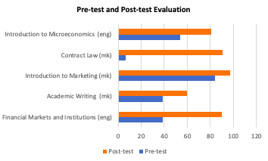
Undergraduate students, concentration FINC, Financial accounting course project. | Summative, indirect, external, comparative;  Fall 2018: Competition encompassing all students enrolled in the Financial Accounting courses, English group - 3 teams - from the Finance and Banking, and the Audit and Accounting study programs. No Macedonian teams competed this year due to lack of enrollment in the Macedonian BSc in Finance and Banking. Under the mentorship of Asst. Prof. Dusica Stevcevska – Srbinoska, PhD, the students presented a marketing and financial analysis of various representatives of the regional and global confectionery industry. The benchmarked companies were Vitaminka AD Prilep (member of the UACS Business Council), Nestle Group, Podravka Group and Evropa AD Skopje. The students had to engage the tools learned in class in order to read and interpret the relevant annual reports, as well as to provide recommendations to company management. The primary financial analysis tools were horizontal and vertical, along with ratio comparison of the competing companies. | Project designed to evaluate all learning objectives for the FA course. All competing groups achieved high scores on the five ILO (ILO surpassing 70%). | Students get passionately involved when working on real cases, such as the Financial Accounting course project (public companies trading on the regional stock exchange). Using project as part of student assessment is highly advisable, especially in upper-level courses. | We will focus on developing the students’ practical skills and knowledge application by using more case studies in the final year of the concentration, which should provide the cognitive and autonomous learning dimension the Macedonian group lacks, according to the contest evaluation results. | 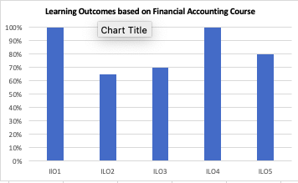
Undergraduate, all concentrations.  To measure the achievement of the program's LO.  In order to demonstrate a mastery of program’s LO (MNGT, MARK, FINC), 3rd year of business students, all concentrations, must score an average of 70% or higher on the summative exit test, | Direct, summative, external, comparative - Exit test.  The Exit test was conducted as part of the on-line Peregrine test for spring 2019.  The Spring 2020 exit test was conducted online, via the Moodle quiz function, in response to COVID-19 confinement measures (Peregrine testing could not be performed). | In 2020/2021, the students demonstrated good achievement of all LO, with LO1 and LO2 reaching the threshold of 70%. | Satisfactory scores were achieved, which demonstrates a well-balanced teaching approach and a solid match to student needs and academic level. | In 2020/2021, the students again took the same questions in a computer-based form (only closed questions), but this time during a pandemic which might have impacted their results. Their results were better in basic knowledge, but worsened as they needed to apply their knowledge and think about more complex issues, which can be attributed to a loss of motivation. | 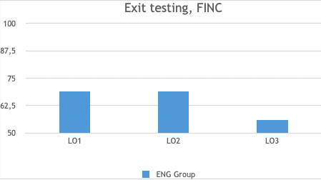
Undergraduate, all concentrations.  To measure the achievement of the program's LO.  In order to demonstrate mastery of program’s LO (MNGT, MARK, FINC), 3rd year business students, all concentrations, must score an average of 70% or higher on the summative exit test. | Direct, summative, external - at the end of the program. | In 2020/2021, the students show good achievement of all LO. The best achievement is on LO1, which is expected, as it is the more basic level of knowledge. This is the highest achievement compared to the previous two years. | Satisfactory scores achieved. | In 2020/2021, the students again took the same questions in a computer-based form (only closed questions), but this time they took the test during a pandemic, which might have impacted their results. They showed better results in the basic knowledge, but their results worsened as they needed to apply their knowledge and think about more complex issues (where they might have lost their motivation to come up with complex solutions). | 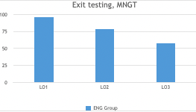
Undergraduate, all concentrations.  To measure the achievement of the program's LO.  In order to demonstrate mastery of program Los, 3rd year of business students, all concentrations, must score an average of 70% or higher on the summative exit test. | Summative, external, direct , comparative.  Students have regular quiz questions during classes.  Mid-term and final exams  Homework  Group Projects evaluation and presentation | In 2020/2021, the students from the English program groups achieve well on all LOs. The best achievement is on LO1 as it is the basic level of understanding marketing concepts. This year the achievement is higher compared to the previous year.  We also administered the same exit test for the students from the Macedonian program groups and, as expected, they showed lower results than the students from the English program groups, but still on a satisfactory level - above 70% or with very small variance below that. | Satisfactory scores achieved. | The difference between the two years’ results in the level of the English program groups is mainly due to the changes in the test administration. Last year, students took a computer-based exit test (same questions in a Peregrine testing format). This year (2020/2021), the students again took the same questions in a computer-based form (only closed questions), but this time in a lockdown conditions, when the last two months were mainly spent mainly at their homes, with a lot of on-line interaction, and were really focused on doing their Marketing course projects.  Regarding the students from the Macedonian program group, from the very beginning, the quality of these students had been on a lower level, and this difference from the other group remained until the end of the studies. This shows that there is a clear difference in the students’ starting knowledge, effort, ambition and career prospects. | 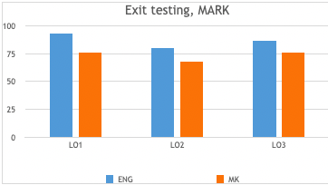
Undergraduate, all concentrations.  To measure the program's LO through the average score of the Capstone project within a core course.  In order to to demonstrate mastery of program Los, on the final Capstone project, business students will have an average score of 70% or higher for each of the concentrations. | Direct, summative, internal, comparative -Capstone project (FINC 3013; FINC 3014 Corporate Finance).  Students were required to prepare project documentation in Word, along with calculations in Excel (with supporting tables used in the original project documentation). The project was presented in class by using Power Point as a tool.  Students were required to prepare an analysis of a business investment decision (starting a new company in an industry of their own preference) by using the project analysis tools studied in this course: WACC, NPV, PI, payback period, IRR, accounting breakeven and EVA, ratio analysis of liquidity, solvency and profitability. Recommendations were given in the concluding part of the document.  Non-finance students were excluded from the Capstone project; instead, they wrote academic essays on various corporate finance topics. | The overall score was well above 70% altogether, and for every LO separately. | Satisfactory scores achieved. | Emphasize application of investment project evaluation tools through more practical cases (in-class).  Increase the use of Excel for in-class and home assignments in order to adopt the application of basic finance instruments when faced with specific investment decisions. | 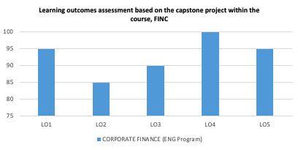
Undergraduate, all concentrations.  To measure the program's LO through the average score of the Capstone project within a core course.  In order to demonstrate a mastery of program Los, on the final Capstone project, business students will have an average score of 70% or higher for each of the concentrations. | Direct, internal, summative, comparative. Success will be measured by using a rubric for the final Capstone project in the core business courses: MNGT Business Planning and Strategy. The Capstone project is directly linked to program’s LO. Students were required to prepare project documentation in Word, along with tables in Excel (with supporting tables used in the original project documentation). The project was presented in class by using Power Point as a tool.  Students were required to prepare a strategic analysis of a business in diary industry and a strategic plan for three consecutive years. | The overall score was well above 70% altogether, and for every LO separately. | The MK students underperform compared to the previous assessment period, while ENG achieved outstanding scores across all programs tested LOs. Also, findings indicate that ENG groups have higher success rates in writing and performing capstone course than MK students. Overall, LO 5 has the lowest score. | Specific curricular changes are not indicated at this time. Additional cases and scenarios will be assigned to all students to be able to learn more from practice and improve the critical thinking and practical skills required for this project. The update of the literature in Macedonian language is needed, there is a lack of translated cases and study materials. | 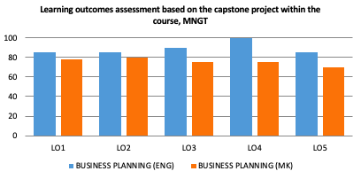
Undergraduate, all concentrations.  To measure the program's LO through the average score of the Capstone project within a core course.  In order to demonstrate a mastery of program Los, on the final Capstone project, business students will have an average score of 70% or higher for each of the concentrations, | Direct, internal, summative, comparative. Capstone was given as a group project. In order to have a smooth and timely implementation, the project was separated into parts and delivered as homework throughout the course. Capstone was given as a team project at the beginning of the course. 2 teams with 3 students per team were participating. The same project (real company) was given to both teams. 3 project LOs were defined. LO1 – demonstrate basic understanding of marketing concepts, consumer behavior, market research and marketing mix principles. LO2 – practical skill, identify and apply appropriate methods and tools to assess the market and consumers, towards devising marketing strategies and tactics. LO3 – competence in formulating and evaluating managerial decision that influences consumer behavior and company performance.  The project was split in 2 parts. The first part was delivered before the mid-term exam, embedding topics in line with the covered material. The second part was delivered after course finalization and, at end, a final project was shared, compiled throughout the year. The designated teams presented the project to their classmates. | Very solid projects based on true insights, extensively incorporating marketing concepts and tools.  Space for improvement of critical thinking and team work / presentation skills.  The overall score for all students is above the benchmark of 70%, which is a great result – it gives a good base for the future marketing projects. | Satisfactory scores achieved. | 1. Existing business example vs. hypothetical example as a project target serves better for the purpose; students have contact with a real company, which contributes towards connecting theoretical knowledge with practice. The recommendation is to continue in the same direction.  2. The weak point is critical thinking regarding theory application – it could be improved as follows:  In-class cases to address solely critical thinking LOs.  Full marketing plan example review at class in groups before the team project finalization  3. Project to be split in a couple of phases, in order to keep the pace and provoke timely work execution, as well as to avoid last minute preparation. | 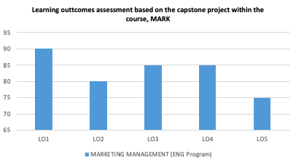
Undergraduate, all concentrations.  To measure the achievement of the SBEM programs' LO (ENG groups).  In order to demonstrate a mastery of the individual program's LO (MNGT, MARK, FINC), 3rd year of business students, all concentrations, must score higher than the Outside US Aggregate. | Summative, external, direct, comparative.  Success will be measured using the Peregrine summative exit test examination for students. In the course of the academic 2018-19, SBEM scheduled its first Peregrine exam for the undergraduate business programs as a comparative summative assessment tool. The exam was conducted in May 2019 and encompassed  the ENG SBEM undergrad programs (students in their last study year). | The ENG undergrads from all concentrations achieved outstanding scores across all tested domains  demonstrating solid knowledge in theory, practical skills and cognitive skills  (overall score of 68.5%). | The comparison of UACS SBEM students to ACBSP Region 8, ACBSP Non-US, and Outside US for the Global Business Education assessments showed clear understanding and ability to apply management, finance and marketing concepts in making decisions. | The evident solid understanding of theoretical concepts and their practical application point out that the applied teaching methods help students develop and achieve the individual program's LO. | 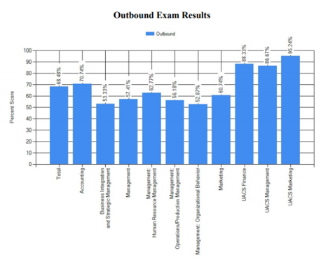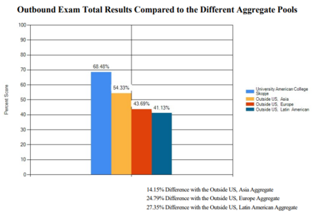  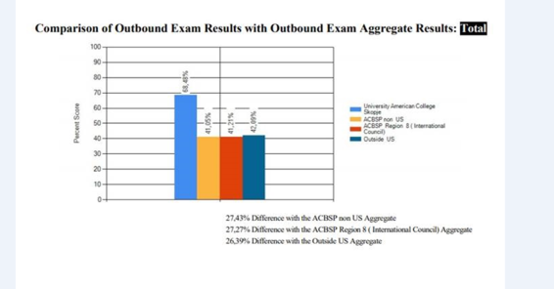
Graduate, MSc. in FINC  To measure the achievement level of program LOs.  The average score of MSc students will be 80% or higher for each of the concentrations, to demonstrate a mastery of the learning outcomes. | Direct, formative, internal, comparative.  Success will be measured by using the portfolio of major assessments (tests, course projects and assignments) from each of the core courses within the program. | The MKD FINC Master students achieved acceptable scores across all tested domains,  demonstrating solid knowledge in theory, practical skills and cognitive skills  (Overall score of 70% or above).  The achievements demonstrated by the ENG FINC Master students lag slightly behind (in the 60-70% range), with ILO3 falling below 60%. | ENG FINC Master students should contribute more to class interaction, particularly in developing critical thinking in regards to theory application. Also, the ILO4’ score (below 70%) indicates a need to further develop communication skills. | In order to enhance intellectual and cognitive skills (i.e. decision making abilities as foreseen by ILO3), instructors need to place greater emphasis on knowledge in interpreting financial data, as well as evaluating investment projects and financial and investment risks issues encountered by financial markets and institutions (ENG groups).  Students need to be more engaged in effective communication through in-class presentations and encouragement of class discussions/round tables (in order to enhance their academic verbal and writing skills). | 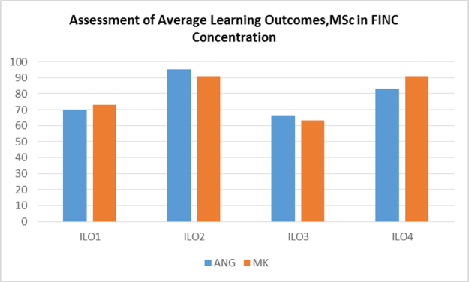
Graduate MA program, MNGT and MARK concentration.  To measure the achievement level of relevant program LO.  In order to demonstrate a mastery of “practical skills” - LO2, MNGT and MARK MA students average rating score by the industry will be at least 4 or higher, on a scale of 1 (poor) to 5 (excellent). | Formative, direct, internal/external.  Success will be measured by using the portfolio of major assessments (tests, course projects and assignments) from each of the core courses within the program. | The MKD MNGT Master students achieved high scores across all tested domains  demonstrating solid knowledge in theory, practical skills and cognitive skills  (score range 70- 85%).  The ENG MNGT Master students achieved a somewhat lower score (in the 60-70% range) in ILO4. | Satisfactory scores achieved which demonstrates a well-balanced teaching approach and a solid match to student needs and academic level.  Given that ILO4 is below 70% (ENG group only), communication skills can be further developed. | Students need to be more engaged in effective communication through in-class presentations and encouragement of class discussions/round tables (in order to enhance their academic verbal and writing skills). | 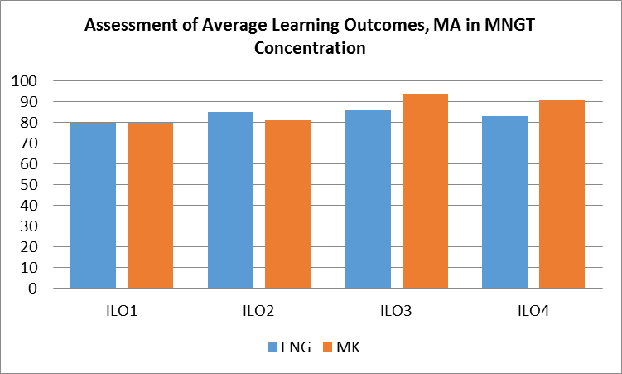
 | Formative, direct, internal/external.  Success will be measured by using the portfolio of major assessments (tests, course projects and assignments) from each of the core courses within the program. | The MKD Marketing Master students achieved high scores across all tested domains  demonstrating solid knowledge in theory, practical skills and cognitive skills  (overall score of 70% or above).  The achievements demonstrated by the ENG MARK Master students are slightly lower, with ILO3 and ILO4 within the 60-70% range. | ENG Marketing Master students should contribute to class interaction more, particularly in the part of developing critical thinking regarding theory application (ILO3 being close to 60%). Also, given that ILO4 is below 70%, the ENG group communication skills can be further developed. | In order to enhance intellectual and cognitive skills (i.e. decision making abilities as foreseen by ILO3), instructors need to place greater emphasis on knowledge in interpreting relevant marketing data for making and implementing strategic decisions for sustainable growth (ENG groups).  Students need to be more engaged in effective communication through in-class presentations and encouragement of class discussions/round tables (in order to enhance their academic verbal and writing skills). | 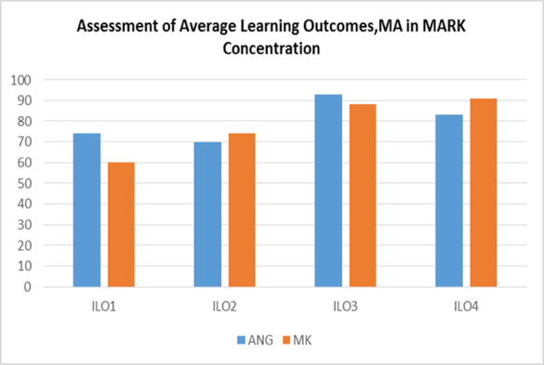
Graduate, MBA  To measure the  achievement level of program LOs.  To demonstrate mastery of the learning outcomes, the average score of MBA students will be 80% or higher for each of the concentrations, in a variety of courses and portfolio of projects. | Direct, formative, internal.  Success will be measured by using the portfolio of major assessments (tests, course projects and assignments) from each of the core courses within the program. | The MKD MBA students achieved high scores across all tested domains  demonstrating solid knowledge in theory, practical skills and cognitive skills  (overall score close to 80%).  The ENG group lags behind on ILO3 with a 60% score. | Students need to enhance their decision-making competence in formulating and evaluating managerial decisions that influence behavior on individuals and groups and the performance of the organization. | In order to enhance intellectual and cognitive skills (i.e. decision making abilities as foreseen by ILO3), instructors need to place greater emphasis on knowledge in interpreting relevant data for making and implementing strategic decisions for sustainable growth (ENG group). | 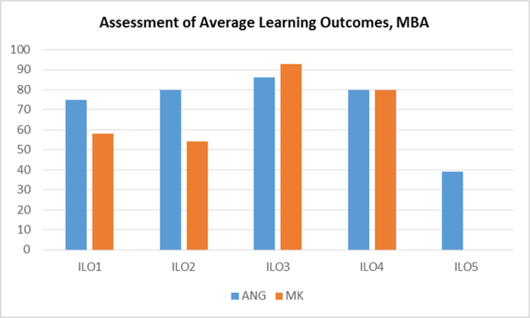
Graduate, MBA program.  To measure the  achievement level of MBA program LOs.  MBA students will have an average score of 80% or higher on their MBA final thesis to demonstrate a mastery of the program’s learning outcomes. | Direct, summative, internal/external.  Success will be measured by using the Marking Sheet Evaluation Form and its standardized rubric, evaluated by faculty and one external evaluator from the industry. | MBA students achieved high scores across all tested domains  demonstrating solid knowledge in theory, practical and cognitive skills, and presentation abilities and self-learning  (score close to or exceeding 80%). | The results demonstrate a well-balanced teaching approach and a solid match to student needs and academic level. | The evident solid understanding of theoretical concepts and their practical application point out that the applied teaching methods help students develop and achieve the individual program's LO. | 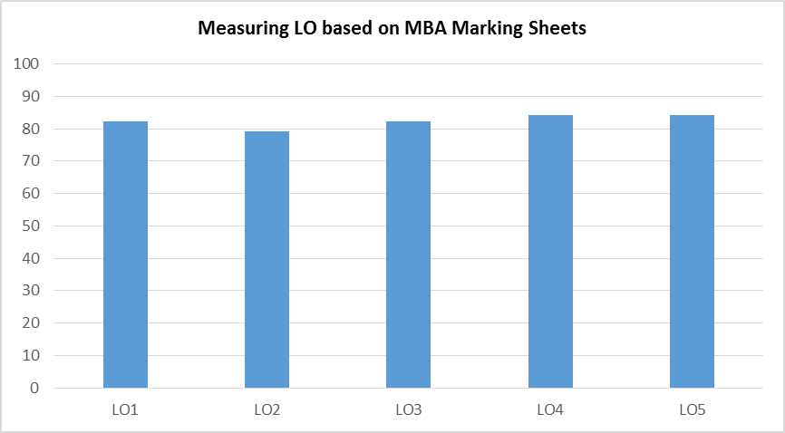
Graduate, MA program, MS program and MBA program To measure learning skills - LO5-students will demonstrate the ability to learn autonomously (or the ability for self-directed learning) and to use their extended study skills. Learning skills self-assessment is conducted with particular emphasis on reading, note-taking, research writing, referencing, and self-assessment. | Indirect, summative, internal.  ILO5 was introduced in the 2018/2019 measurements. Success measured by using a self-evaluation survey conducted during the Master thesis seminar (participants: all Master students in their writing thesis stage). The survey is directly linked to graduate programs' LO5. Students were required to assess their learning skills and self-direction by answering 25 questions. Answers were anonymous. | In order to conduct a thorough analysis, students were divided in 3 groups: MBA, Master (Eng), and Master (Mk).  Scoring above 70% on evaluating arguments, ability to separate main ideas and supporting evidence in sources, understanding the material, swift proofreading and drafting assignments, finding sources and referencing. Highest score (cca.90): defining themselves as active, independent learners. | Overall satisfactory level of self-study capacity at the graduate level given the multiple scores above a 70% threshold. The group indicates a lack of skills in finding relevant sources using databases, formal writing and use of academic vocabulary, and referencing. MK Master group handles exams better than assignments. MA Eng needs improvement, given their lowest scores in overall self-evaluation in comparison to MBA and MA Mk students. | Provide guided reading materials and teaching of academic writing in class and for projects in order to ease the acquisition of knowledge for academic writing styles and vocabulary.  Graduate-level instructors should offer more support in use of databases for the purpose of detecting relevant sources and emphasize referencing tools and guidelines in assignments. | 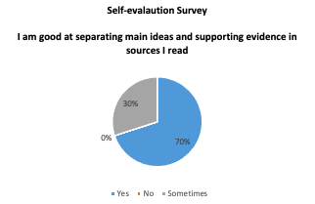  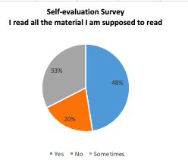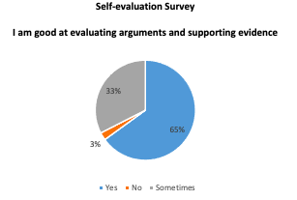

PART V – Faculty & Staff
Criterion 5.1 Human Resource Planning
The business unit will have a human resource plan that supports its strategic plan. In a brief statement here, explain your HR plan’s relationship to your strategic goals.
Table 5.1 UACS sessions 2020-2021
In the period 2020-2021 HR Policies were linked with achieving goals like: Creating a Learning organization; Overcoming Silo Vision; Establishment of cross Functional teams.
Criterion 5.2 Employment Practices
Criterion 5.2.1
The business programs must show how the composition of the full-time and part-time faculty (in terms of their practical experience and academic credentials) matches program objectives.
- how the composition of your faculty provides for intellectual leadership relative to each program’s objectives;
At UACS, courses and programs are designed to offer theoretical and practical knowledge that provides quality in the educational process.
Table 5.2.1 In this table is presented the number of full-time and part-time professor, as well as the number of visiting professors in academic year 2020-2021

School of Business Economics and Management
Teaching Staff with PhD |  | Teaching staff without PhD |  | Visiting Professors |  | Total
Part-Time | Full-Time | Part-Time | Full-Time | PhD | Non PhD | 52
16 | 11 | 17 | 3 | 4 | 1

Table 5.2.2 There is a balance between FT Faculty with a degree earned abroad and at home
FULL-TIME FACULTY MEMBERS | Year of initial appointment | Highest Degree |  | Earned | Assigned Teaching Discipline/s | Graduate credits in the fields | Prof. Cert. | Level of Qualification
 |  | Type | Discipline |  |  |  |  |  | Tenure/Contract
Marjan Bojadjiev | 2005 | PhD | Economics | MK | Leadership and Organizational Behavior | Yes | CMC, Bank License | AQ | T
Venera Krliu-Handjiski | 2014 | PhD | Economics  Sociology | MK | Sociology and Organizational Behavior | Yes  (p.5) |  | AQ | C
Tome Nenovski | 2010 | PhD | Economics | MK | Public Finance, Macroeconomics, Banking | Yes | Bank License | AQ | T
Marjan Petreski | 2009 | PhD | Economics | UK | Monetary Economics, Statistics, International Money and Finance | Yes |  | AQ | T
Snezhana Hristova | 2013 | PhD | Economics | Netherlands / MK | Management, Accounting, International Management | Yes |  | AQ | C
Ana Tomovska-Misoska | 2009 | PhD | Psychology | UK | HRM, Psychology, Consumer Behavior | She added HR courses (Certificate for HRM, HR Development& Training, Swiss Management Center |  | AQ | T
Dusica Stevchevska-Srbinovska | 2017 | PhD | Finance and Financial Management | MK | Accounting and Corporate Finance | Yes |  | PQ/AQ | C
Miodraga Stefanovska Petkovska | 2010 | PhD | Social Sciences | MK | Sociology, Social work and policies, Organizational behavior | Yes  (p.5) |  | AQ | C
Dimitar Kovachevski | 2012 | PhD | Economics | Montenegro | Marketing | Yes |  | AQ | C
Ilijana Petrovska | 2009 | PhD | Economics | MK | Marketing | Yes |  | AQ | T
Elena Bundaleska | 2012 | PhD | Economics | U.S. /MK | Contract Law, Business Ethics | Yes  (p.5) |  | AQ | C
Marija Andonova | 2013 | MBA | Mathematics | MK | Business Mathematics, Introduction to Statistics | Yes |  | PQ | C
Maja Kadievska Vojnovikj | 2019 | MBA | Finance | Greece | Microeconomics, Macroeconomics | Yes |  | PQ | C
Ivona Mileva | 2018 | MSc | Management | Monaco | Leadership, Entrepreneurship, Organizational Behavior | Yes |  | PQ | C
Stefan Tanevski | 2020 | Bachelor | Accounting and Audit | MK | Accounting, Statistics | No |  |  | C

- how the composition of your faculty provides for required depth and breadth of theory and practical knowledge to meet your student learning outcomes.
Considering the above, the composition of the faculty members is selected carefully in accordance with the UACS bylaws and HR Policy and foremost in accordance with each program learning outcomes. Theoretical and practical knowledge is transferred by providing sufficient number of professors in theory, and experts in the field for the practical knowledge transferred to the students. Guest lecturers as well as field studies is encouraged in each course and practices at least once during the entirety of the course.
Criterion 5.2.2
In your institution’s use of multiple delivery systems and/or your program’s use of part-time (adjunct) faculty, your human resource management process must include policies for recruiting, training, observing, evaluating, and developing faculty for these delivery systems Explain or describe:
- how you develop qualified full-time and part-time faculty members.
After the recruitment of a new Faculty at UACS, he/ she is undergoing the process of learning and training.
Socialization and training: There are Socialization Seminars organized, which also represents one of the preconditions for start the teaching process.
At the beginning of each semester UACS organizes a seminar for induction of the new faculty. In addition to the new members of the UACS family, this seminar is available for all existing members of UACS who consider it useful.
Mentorship program at UACS ; Apart from it, each new teacher is assigned a mentor- teacher, who is working on the design of the syllabus, examination, grading structure, etc.
UACS has several programs for training and orientation

Table 5.3 Programs for training and development
Master and Doctoral Degrees for faculty and administration | UACS offers to all of its members a first, second and third cycle education.
Research Seminar Series – RSS | Seminars designed to facilitate the process of research experience and the exchange of practical advices among faculty and to enable higher level of involvement of the faculty in research-related activities.
Other external trainings | UACS supports external trainings related to the necessity for professional advancement of its members (in particular of administration)
External Collaboration Events | After the cease of RESITA network, most of UACS activities are linked with Erasmus and / or CEEPUS as well as with TOR VERGATA
International Teaching Experiences | Assoc. Prof. Ilijana Petrovska, PhD- Visiting professor at University Tor Vergata, Italy.  Prof. Marjan Bojadjiev, PhD delivered lectures at University Tor Vergata, Italy.
“Be a host” Program | Is a policy that faded away, but in fact, there is always responsible faculty team who takes care about the visiting professors.

- how you orient new faculty members to the program;
Socialization and Training Seminar – at the beginning of each semester UACS organizes a seminar for induction of the new faculty. In addition to the new members of the UACS family, this seminar is available for all existing members of UACS who consider it useful to renew or expand their own knowledge on bylaws, course content and conduct etc.
Active participation on the faculty council meetings
- how you orient new faculty members to assigned course(s);
- how you provide opportunity for part-time and/or full-time faculty members to meet with others teaching the same courses.
- how you provide guidance and assistance for new faculty members in text selection, testing, grading, and teaching methods.
The points c, d and e and resolved in a similar manner

Table 5.4 (c, d and e)
The Role of the Dean / Vice Dean | Orientation, Counseling
Faculty Council and Department meetings | At the Faculty Councils all Faculty members are invited.  The same is even more for department meetings  (Marketing; Management, Finance)
Mentor Protégé Relations | The Dean will assign formally or informally Mentors
Shared Experiences | The teaching experiences are shared on the Teaching Improvement Seminars.
Opportunity consult with a professor that teaches a course within the same discipline | Importance on the course content, learning outcomes and delivery methods that are in accordance with UACS bylaws and practices are highly stressed.

- how you provide for course monitoring and evaluation.
The monitoring is of a twofold nature.
During the course – usually there will be a faculty council that discusses the results, experiences etc.
At the end of the course: Student evaluation as part of the 360 evaluations. Bell Curve Grading, Students evaluate the course and instructor teaching the course at the end of each course.
The students are attending Quality Circle Meetings, where they have opportunity to share experiences about the faculty staff, through which the Dean of SBEM get additional evaluation for the faculty members.

Criterion 5.3. Faculty Qualifications, Workload, and Coverage
Criterion 5.3.1
The composition of the faculty must include sufficient academic credentials and business or professional experience to ensure appropriate emphasis on both business theory and practice to meet program objectives.
The structure of the faculty contributes to steering creativity, critical reasoning and intellectual curiosity of the students. UACS applies the rule of 33:33:33 when it comes to teaching (for the English programs). This means that UACS strives to have:
- 1/3 of the curricula to be taught by academicians and professors with terminal degree in the area in order to provide students with solid theoretical knowledge which is an essential prerequisite for critical reasoning. In addition, these academicians are encouraged to research and publication activities which activates their creativity as well and this creativity we expect to be transferred to the students.
- 1/3 of the curricula to be taught by industry professionals which can relate the theoretical background to the country-specific industry context so students can develop a more critical eye on the current developing and idea s how to overcome potential obstacles
- 1/3 of the faculty to be internationally recognized experts or academicians who can provide to students a broader vision and insight on how problems are tackled in different countries and across different cultures. For the Macedonian teaching programs, the rule is 50:50. This implies that:
- ½ of the curricula should be taught by academicians or researchers with highest terminal degree.
- ½ of the curricula should be taught by industry experts of professors of management practice

Graph 1. Composition of UACS SBEM faculty

Instructors of practice | Teacher Assistant | Assistant Prof. | Associate Prof. | Prof. | Teaching Staff |  | Visiting professors | Total Number
 |  |  |  |  | Part-time | Full-time
26 | 3 | 4 | 6 | 8 | 33 | 14 | 5 | 52

Criterion 5.3.2.a
Document every full-time and part-time faculty member teaching courses in the business unit. A recent curriculum vitae (not more than two years old) for all business faculty should be provided and included as an appendix in the self-study report.
Criterion 5.4 Faculty Deployment
Faculty Deployment Criterion - Each school or program must deploy faculty resources among the disciplines, units, courses, departments, and major fields to ensure that every student attending classes (on or off campus, day or night, or online) will have an opportunity to receive instruction from an appropriate mix of the faculty to ensure consistent quality across programs and student groups. For each academic major offered, a school or program must provide sufficient academic leadership at each location where the program is offered to ensure effective service to students and other stakeholders
Table 5.4 Teaching Load per semester
Note: For the graduate studies, lectures are scheduled in two weeks. The total number of hours lectured for every course is 20 hours plus 4 hours for exam, with an exception for groups with 5 students or less (in this cases the total number of lectures is 8 hours + exam). Every course is divided to be lectured in two weeks, 10 hours in total during the first week (usually Thursday, Friday, and Saturday), and 10 hours during the second week.

Criterion 5.4.2. - The business unit must ensure that sufficient human resources are available at each location to provide leadership (including advising and administration) for each program and that assessment processes are in place to ensure that this leadership is being provided.
UACS has one location only.
Criterion 5.5 Faculty Size and Load
Criterion 5.5
Though other qualified individuals may participate in these functions, the faculty must play an essential role in each of the following: classroom teaching assignments, student advising and counseling activities, scholarly and professional activities, community and college service activities, administrative activities, business and industry interaction, special research programs and projects, thesis and dissertation supervision and direction, if applicable travel to off-campus locations and/or non-traditional teaching, if applicable.

- how you determine the appropriate teaching load for your faculty members;
UACS has a bylaw on Academic-Administrative Load (AAL) which regulates the number of contact-hours for undergraduate and graduate program, mentorships of bachelor and master thesis and thus like. With the AAL, UACS prescribes an expected number of contact-hours that professors should have with students and other activities.

Table 5.5 –Table for Faculty Load (2020-2021)

The Bylaw is based on the experiences of similar and highly recognized international universities as well as on the compulsory criteria of the international accreditations UACS obtained.
If a professor is also assuming an administrative position (such as Department head, vice-dean, dean) their teaching and research load is reduced in order to provide sufficient time for the other duties.

- how you demonstrate that the faculty and staff are of sufficient number to ensure performance of the above nine functions;
Table 5.5.2 Students / Faculty Ratio
Students/Faculty Ratio
Academic Year 2020-2021 | School of Business Economics and Management | 11,8

- the institutional policy that determines the normal teaching load of a full-time faculty member;
UACS has a bylaw on Academic-Administrative Load (AAL) which regulates the number of contact-hours for undergraduate and graduate program, mentorships of bachelor and master thesis and thus like, as explained above in 5.5.1.a .
- how the combination of teaching and other responsibilities for full- and part-time faculty members is consistent with fulfilling all nine functions effectively;
The above mentioned AAL policy as well as its implementation proves that the UACS faculty do have enough time to fulfill their functions effectively, as it can be seen in Table 5.6.

- how your part-time faculty members participate in these essential functions.
The part-time faculties participate on the Faculty Council al Meetings of the schools where they teach and through these meetings they are actively involved in the process of defining their workload corresponding to their daily activities and to student’s demands. In addition, part-time faculties are actively involved in curricula development because UACS believes that their contribution as industry experts is very important.

Criterion 5.5.2
A faculty member who is extensively engaged beyond what is normally expected in any one of the nine functions (e.g., one who teaches graduate level courses, has significant administrative duties, directs multiple graduate theses and/or dissertations, or is engaged in extensive approved research) should have an appropriate reduction in other professional responsibilities. Explain your institution’s policies with respect to the granting of release time for faculty members performing the sorts of exceptional duties
The plan for the workload of the professors which corresponds to qualifications is prepared before the beginning of the academic year. Deans have reduced load, i.e. Deans should have not more than 9 hours teaching load weekly.

Criterion 5.6 Faculty Evaluation
Each program must have a formal system of faculty evaluation for use in personnel decisions, such as the awarding of tenure and/or promotion, as well as retention. This system must also provide processes for continuous improvement of instruction through formative evaluations. This standard requires justification of personnel decisions based on the mission of the programs. The actual system of annual evaluation is within the jurisdiction of the individual school or program. The system of evaluation must provide for some measurement of instructional performance and should consider related areas as appropriate, not limited to these topics:
Criterion 5.6.1. a,b,c,d,e
- how you monitor/evaluate your faculty’s teaching
The 360 degree evaluation adopted at UACS in 2011, aims at assisting each member of the UACS family develop and progress, improve the work of the instructors and administrative staff at the University American College Skopje. The purpose of the evaluation is to provide:
- proper and on-time feedback to all members of the UACS family;
- to provide adequate appraisal of each individuals as well as groups of UACS;
- to differentiate between those who have distinguished results and those who have less distinguished results;
- adequately to award those who have outstanding results (as individuals or groups);
- to provide feedback information to those who do not have outstanding results in the areas where improvement is warm welcomed and would be appropriate;
- to provide inputs for professional development for next year;
- to provide the distinguished achievers with accelerating career growth according to the AAL policy;
- to provide adequate feedback from all stakeholders in the process of delivery of services, including but not limited to: students, faculty members, relevant members of the administration, deans, Rector and others;
- to mark the underperformance, thus enabling the organization to have a sustainable permanent growth.

The Evaluation by students is considered to be one of the key pillars of the 360 evaluation. The Evaluation by students is conducted at least once per semester, usually the last teaching class.

- how you monitor/evaluate your faculty’s student advising and counseling
Faculty’s student advising and counseling is carried out constantly and there is no specific and strict procedure for doing so. UACS has embodied a culture where students are enabled to communicate with each professor freely and attend individual meetings during allotted office hours. Each School at UACS during its faculty meetings discusses issues which are related with offering advising and counseling to the students. If issues are at place and needs attention they are discussed as solved during these meeting where if necessary students are present as well. Another procedure which is taking place and it is used for advising and counseling is the Quality Circle process in which students take active participation by engaging themselves in special meetings with the Deans of the UACS School, on which they discuss their potential issues and problems they have during their studies. Also, students are always advised to follow the Grievance policy and communicate with the Grievance officer in case they have issues with any aspect of their studies.

- how you monitor/evaluate your faculty’s scholarly, professional, and service activities (see glossary of terms for scholarly activities).
At UACS, in 2011 a Committee for science and research has been formed, with the scope to monitor the faculty development in the area of scientific and research work. Part of the 360 Evaluation is also an evaluation performed on the basis of faculty results in one academic year. The Evaluation is conducted by the appointed Vice Rector for research once a year, usually at the beginning of the new academic year, and a report is compiled with all research and scholarly work for the faculty of each school.
In reference to the professional and service activities, UACS monitors the progress of the faculty members by their professional development plan and report and through the organization of several professional development seminars throughout one academic year. These activities are also reported in the AAL.

- how your faculty and staff demonstrate and promote a student focus.
Every year, UACS rewards members with strong commitment to professional development to attend a training by the European Foundation for Entrepreneurial Research (EFER) in order to get introduced with this method of teaching and then to exchange their knowledge with the other UACS members.
- how your compensation and recognition approaches for individuals and groups, including faculty and staff, reinforce the overall work system, student performance, and learning objectives,
UACS bylaw on Academic-Administrative Load (AAL) and 360 Evaluation are matched after each academic year in order to compare results and performances especially in what concerns teaching activities and the level of satisfaction expressed by the students in the evaluation questionnaires.
After the performed 360 Evaluations, scores are prepared for each faculty members and according to the results the faculty members with the best scores are rewarded by giving them explicit recognition of their great performance and hard work.
This is seen as great incentive and motivation for the other colleagues for the upcoming academic year. The recognition activities range from increase of salaries, through paid memberships in professional organizations, journals, paid participation in conferences, etc.

- how you improve your faculty/staff evaluation system.
The evaluation system in place at UACS is improved through reviewing process at the end of each year, taking into consideration the performances and results in the previous academic year.
Suggestions from both academic and administrative staff is taken into consideration in regard to the policy itself, the questionnaires used, the assigned weights etc.

Criterion 5.7 Faculty and Staff Operational Procedures, Policies and Practices and Development
Criterion 5.7.1
Each institution (school or program) must have a written system of procedures, policies, and practices for the management and development of faculty members. Written information on all of these must be available to faculty and staff members.
All UACS bylaws, procedures and decisions concerning the overall work of the university in general, and at Schools ‘level in specific are placed in an organize system as electronic database. All bylaws, procedures and decisions as well as policies are available internally to all faculty members and administration for consultation, through their designated electronic accounts connected with their email addresses.
Bylaws, procedures and policies are improved and revised on ad-hoc basis, depending on a situation at hand, following strictly new laws and amendments in the country. If there is a need of a revision of UACS act, meetings are held as well as open forums are organized where all faculty members can express their comments and concerns and propose amendments and text if necessary.
UACS bylaws are available at the following link UACS Bylaws.

Criterion 5.7.2
Each business program must provide an opportunity for faculty and staff development consistent with faculty, staff, and institutional needs and expectations. Part-time faculty members should participate in appropriate faculty development activities. Please describe or explain:
- how you determine faculty and staff development needs;
Each faculty member has the freedom to choose a track in which they desire to develop and progress (research, academic or administrative). The academic advancement is related to fulfillment of specific criteria stipulated in the Higher Education Act of the Republic of Macedonia (e.g. the official title and number of publications, which determine the academic level/title and the amount of classes per week), while the other two tracks are not directly related to national legislation, but are defined at UACS level.

b. how you get input from the faculty and staff about their development needs;
c. whether the faculty and staff development process employs activities, such as sabbaticals, leaves of absence, grants,
provision for student assistants, travel, clerical, and research support, etc.
The paid leave and sabbaticals of the faculty or the administration are set out in the Bylaw on the Academic-Administrative Load of UACS. A faculty can take a semester off to finalize their doctoral thesis or up to one month off to finalize a master thesis. Sabbaticals are also possible on the simple grounds that the absence is planned well in advance, so that a suitable replacement for the particular faculty member is found before the commencement of the classes. Funding and grants for research, business trips to attend conferences or seminars etc. are set out in the Scientific and Research Activity Act.

Criteria 5.8 Scholarly and Professional Activities
Criterion 5.8.1
Faculty members must be actively involved in professional activities that will enhance the depth and scope of their knowledge and that of their disciplines, as well as the effectiveness of their teaching. The institution must demonstrate a reasonable balance of scholarly and professional activities by the faculty as a whole.

PART VI – Education & Business Process Management
Criterion 6.1.1
Educational programs must describe and explain approaches to the design of educational programs and offerings, its method(s) of making curricular changes related to the school’s or program’s mission statement and strategic plan, and its use of student and stakeholder input in these processes.
UACS has tried to get input from the Business Council on the Curricula development. However, the amendments on the Curricula design are result of the discussions on the faculty Council and Rector’s Board. Changes in accreditations and curricula were conducted.

Criterion 6.1.2
Degree Program Delivery Describe the degree program delivery for each degree program. To fulfill this criterion, you must provide the following information:
- the length of time that it takes for a full-time student to complete the degree (both as cataloged and actually, on-average);
The minimum time for the student to obtain a degree is three (3) years, if he/she timely pass all exams. During the studies, the student should pass the 6 semesters in order to graduate. UACS offers undergraduate studies with duration of 3 years, during which the student acquires a minimum of 180 ECTS and a degree title in the specified field.
The Graduate studies offer the possibility of acquiring the title Specialist or Master in the specified academic field. The specialization studies last 1 year and the student obtains 240 ECTS, which is equivalent to U.S. Bachelor. The Master's degree lasts for 2 years, and the student obtains 300 ECTS.
UACS employs the European model of continuous education. This includes an accelerated baccalaureate degree program as well as extended studies at the graduate level. The programs for undergraduate and graduate levels are designed to be completed in 3+1+1 years, with the full option of transferring credits from other accredited institutions.

- the number of contact (coverage hours or equivalent) hours required to earn three (3) semester hours (four (4) quarter hours) of credit or equivalent; and
While taking courses, students earn academic credits: the European Credit Transfer System (ECTS) suggest 25 hours of learning time per academic credit. Usually, the basic and intermediary courses carry 6 ECTS, and advanced courses 8 ECTS.

- if your unit confers nontraditional degrees, such as accelerated, competency based, executive, etc., specially designed to meet the needs of specific stakeholders other than traditional college students, etc., describe how
Currently at the University American College such types of non-traditional programs are not offered.
Programs | Time to degree | ECTS | Delivery method
MBA (4years+1year) | 2 semesters | 60 | Classroom
MBA (3years+2years) | 4 semesters | 120 | Classroom
MA/MS (4years+1year) | 3 semesters | 90 | Classroom
Bachelor (3years) | 6 semesters | 180 | Classroom/Part time

Criterion 6.1.3 Undergraduate Common Professional Component (CPC)
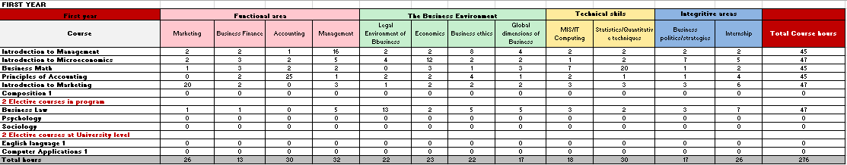

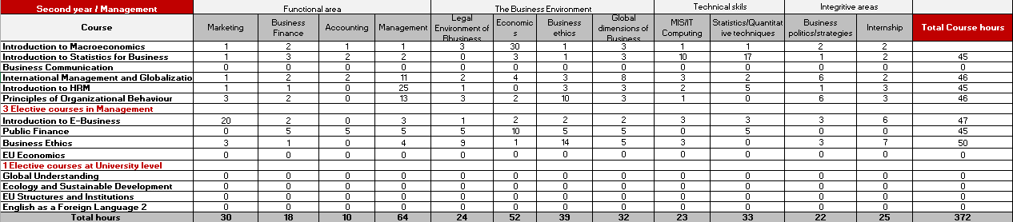
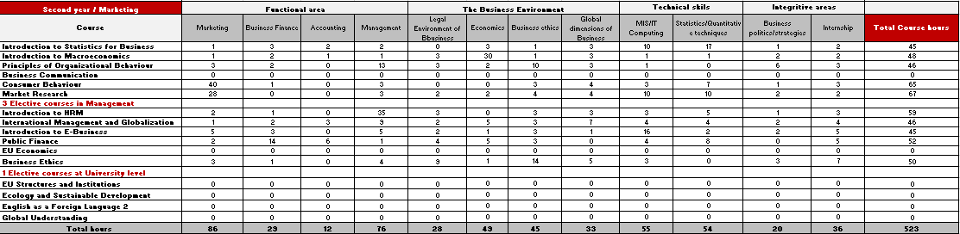
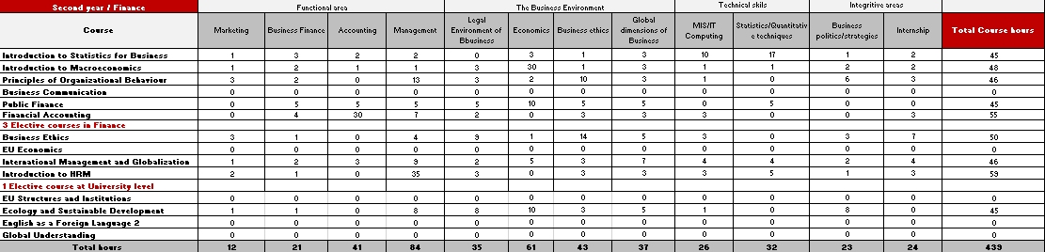
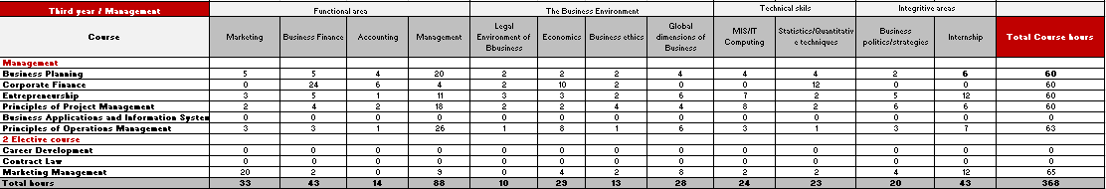
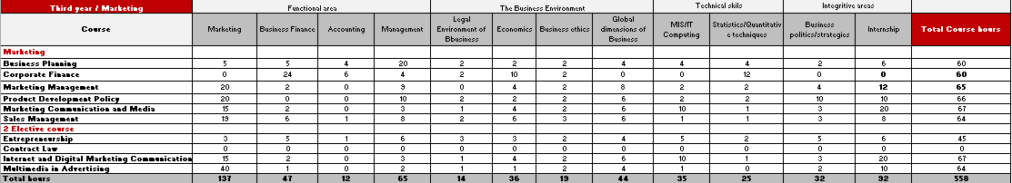
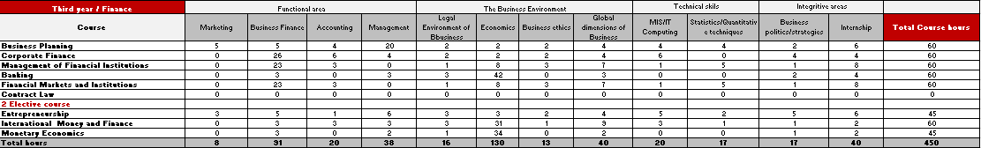

Criterion 6.1.7.
Report and explain your methods and processes for program evaluation.
School of Business Economics and Management
Undergraduate Program, English Language Group
Description
 | 2009-10 | 2010-11 | 2011-12 | 2012-13 | 2013-14 | 2014-15 | 2015-16 | 2016-17 | 2017-2018 | 2018-2019 | 2019-2020 | 2020-2021
Number of students who enrolled in year 1 | 56 | 65 | 64 | 56 | 39 | 31 | 41 | 43 | 53 | 79 | 65 | 59
Number of students who enrolled in year 2 | 48 | 54 | 56 | 50 | 35 | 20 | 30 | 33 | 41 | 63 | 51
Progress rate from 1 to 2 year | 85,71% | 83,08% | 87,50% | 89,29% | 89,74% | 64,52% | 73,17% | 76,74% | 77,36% | 79,75% | 78,46% | 0,00%
Number of students who enrolled in year 3 | 46 | 51 | 54 | 47 | 33 | 17 | 25 | 30 | 35 | 53 | 44
Progress rate from 2 to 3 year | 95,83% | 94,44% | 96,43% | 94,00% | 94,29% | 85,00% | 83,33% | 90,91% | 85,37% | 84,13% | 86,27% | 0,00%
Average GPA in 1 year | 2,55 | 2,64 | 2,64 | 2,40 | 2,61 | 2,36 | 2,31 | 2,57 | 2,50 | 2,51 | 2,58 | 2,63
Average GPA in 2 year | 2,64 | 2,79 | 2,57 | 2,57 | 2,38 | 2,81 | 2,55 | 2,88 | 2,74 | 2,73 | 2,71
Average GPA in 3 year | 2,55 | 2,52 | 2,52 | 2,50 | 2,65 | 2,68 | 2,66 | 2,75 | 2,61 | 2,69 | 2,90
Number of students on probation/under a special regime | 5 | 14 | 7 | 13 | 4 | 12 | 11 | 2 |  |  | 5
Rate of students on probation/under a special regime | 10,87% | 27,45% | 12,96% | 27,66% | 12,12% | 70,59% | 44,00% | 6,67% | 0,00% | 0,00% | 11,36% | 0,00%
Number of students on stand by | 3 | 1 | 0 | 1 | 0 | 0 | 0 | 2 |  | 1 | 8 | 9
Rate of students on stand by | 6,52% | 1,96% | 0,00% | 2,13% | 0,00% | 0,00% | 0,00% | 6,67% | 0,00% | 1,89% | 18,18% | 0,00%
Number of students who cancelled their studies | 4 | 8 | 5 | 6 | 3 | 6 | 2 | 1 | 7 | 4 | 4 | 1
Rate of retained students | 92,86% | 87,69% | 92,19% | 89,29% | 92,31% | 80,65% | 95,12% | 97,67% | 86,79% | 94,94% | 93,85% | 98,31%
Rate of students who cancelled their studies | 7,14% | 12,31% | 7,81% | 10,71% | 7,69% | 19,35% | 4,88% | 2,33% | 13,21% | 5,06% | 6,15% | 1,69%
Number of students who finished in 3 years | 32 | 35 | 41 | 36 | 22 | 13 | 21 | 19 | 21 | 41
Number of students who finished in 4 years | 2 | 6 | 9 | 2 | 3 | 0 | 4 | 1 |  | 2
Number of students who finished in 5 years | 1 | 1 | 1 | 0 | 0 | 0 | 0 |  |  | 0
Number of students who finished in 6+ years | 0 | 0 | 0 | 0 | 0 | 0 | 0 |  |  | 0
Average time to complete studies (years) | 3,11 | 3,19 | 3,22 | 3,05 | 3,12 | 3,00 | 3,16 | 3,05 | 3,00 | 3,05 | 0,00 | 0,00
Rate of students who have completed the studies in the prescribed period | 57,14% | 53,85% | 64,06% | 64,29% | 56,41% | 41,94% | 51,22% | 44,19% | 39,62% | 51,90% | 0,00% | 0,00%
Rate of students who have not completed the studies in the prescribed period | 5,36% | 10,77% | 15,63% | 3,57% | 7,69% | 0,00% | 9,76% | 2,33% | 0,00% | 2,53% | 0,00% | 0,00%
Rate of graduate students | 62,50% | 64,62% | 79,69% | 67,86% | 64,10% | 41,94% | 60,98% | 46,51% | 39,62% | 54,43% | 0,00% | 0,00%
Average GPA of GPA graduates in 3 years | 2,84 | 3,08 | 2,81 | 2,69 | 2,77 | 2,90 | 2,67 | 2,79 | 2,77 | 2,70
Average GPA of GPA graduates in 4 years | 1,96 | 1,75 | 2,14 | 2,04 | 1,95 |  | 2,08 | 3,2 |  | 1,97
Average GPA of GPA graduates in 5 years | 2,33 | 2,15 | 1,70
Average GPA of GPA graduates in 6+ years

Undergraduate Program, Macedonian Language Group
Description
 | 2009-10 | 2010-11 | 2011-12 | 2012-13 | 2013-14 | 2014-15 | 2015-16 | 2016-17 | 2017-2018 | 2018-2019 | 2019-2020 | 2020-2021
Number of students who enrolled in year 1 | 92 | 62 | 52 | 48 | 29 | 45 | 24 | 20 | 33 | 29 | 21 | 32
Number of students who enrolled in year 2 | 80 | 54 | 44 | 37 | 21 | 30 | 16 | 15 | 22 | 19 | 17
Progress rate from 1 to 2 year | 86,96% | 87,10% | 84,62% | 77,08% | 72,41% | 66,67% | 66,67% | 75,00% | 66,67% | 65,52% | 80,95% | 0,00%
Number of students who enrolled in year 3 | 73 | 49 | 35 | 36 | 21 | 28 | 16 | 14 | 19 | 17 | 16
Progress rate from 2 to 3 year | 91,25% | 90,74% | 79,55% | 97,30% | 100,00% | 93,33% | 100,00% | 93,33% | 86,36% | 89,47% | 94,12% | 0,00%
Average GPA in 1 year | 2,16 | 2,21 | 2,06 | 2,28 | 2,14 | 2,02 | 2,36 | 2,30 | 1,93 | 2,09 | 2,24 | 2,60
Average GPA in 2 year | 2,28 | 2,34 | 2,18 | 2,64 | 2,26 | 2,54 | 2,73 | 2,42 | 2,56 | 2,50 | 2,50
Average GPA in 3 year | 2,09 | 2,14 | 2,26 | 2,37 | 2,23 | 2,49 | 1,94 | 2,39 | 2,48 | 2,68 | 2,80
Number of students on probation/under a special regime | 27 | 18 | 16 | 19 | 8 | 18 | 6 | 6 |  | 6 | 4 | 7
Rate of students on probation/under a special regime | 36,99% | 36,73% | 45,71% | 52,78% | 38,10% | 64,29% | 37,50% | 42,86% | 0,00% | 35,29% | 25,00% | 0,00%
Number of students on stand by | 4 | 3 | 2 | 1 | 1 | 1 | 0 | 0 | 1
Rate of students on stand by | 5,48% | 6,12% | 5,71% | 2,78% | 4,76% | 3,57% | 0,00% | 0,00% | 5,26% | 0,00% | 0,00% | 0,00%
Number of students who cancelled their studies | 7 | 6 | 7 | 9 | 5 | 7 | 6 | 1 | 9 | 6 | 1 | 3
Rate of retained students | 92,39% | 90,32% | 86,54% | 81,25% | 82,76% | 84,44% | 75,00% | 95,00% | 72,73% | 79,31% | 95,24% | 90,63%
Rate of students who cancelled their studies | 7,61% | 9,68% | 13,46% | 18,75% | 17,24% | 15,56% | 25,00% | 5,00% | 27,27% | 20,69% | 4,76% | 9,38%
Number of students who finished in 3 years | 43 | 32 | 26 | 28 | 13 | 15 | 12 | 8 | 15 | 14
Number of students who finished in 4 years | 11 | 6 | 4 | 2 | 2 | 4 | 0 | 1
Number of students who finished in 5 years | 4 | 3 | 1 | 0 | 0 | 0 | 0 | 0
Number of students who finished in 6+ years | 4 | 3 | 0 | 0 | 0 | 0 | 0 | 0
Average time to complete studies (years) | 3,50 | 3,48 | 3,19 | 3,07 | 3,13 | 3,21 | 3,00 | 3,11 | 3,00 | 3,00 | 0,00 | 0,00
Rate of students who have completed the studies in the prescribed period | 46,74% | 51,61% | 50,00% | 58,33% | 44,83% | 33,33% | 50,00% | 40,00% | 45,45% | 48,28% | 0,00% | 0,00%
Rate of students who have not completed the studies in the prescribed period | 20,65% | 19,35% | 9,62% | 4,17% | 6,90% | 8,89% | 0,00% | 5,00% | 0,00% | 0,00% | 0,00% | 0,00%
Rate of graduate students | 67,39% | 70,97% | 59,62% | 62,50% | 51,72% | 42,22% | 50,00% | 45,00% | 45,45% | 48,28% | 0,00% | 0,00%
Average GPA of GPA graduates in 3 years | 2,53 | 2,49 | 2,32 | 2,62 | 2,47 | 2,83 | 2,76 | 3 | 2,59 | 2,5
Average GPA of GPA graduates in 4 years | 1,95 | 1,93 | 2,02 | 1,85 | 1,67 | 1,79 |  | 2,81
Average GPA of GPA graduates in 5 years | 1,70 | 1,77 | 1,73
Average GPA of GPA graduates in 6+ years | 1,81 | 1,82

Graduate Program
MA English 3+1 - Specialization | 2012-2013 | 2013-2014 | 2014-2015 | 2015-2016 | 2016-2017 | 2017-2018 | 2018-2019 | 2019-2020 | 2020-2021
Enrolments in year 1 | 1 | 8 | 2 | 4 | / | 1 | 2 | 4
Number of progressing to year 2
Average GPA per pass exam - entered year 1 | 3,10 | 3,11 | 3,58 | 2,92 |  | 3,19 | 2,33 | 3,05
Average GPA per pass exam - entered year 2
Number of graduated | 1 | 3 | 1
Number of students who passed all exams |  | 3 | 1 | 1 |  | 1 |  | 3
MA English 3+2 | 2012-2013 | 2013-2014 | 2014-2015 | 2015-2016 | 2016-2017 | 2017-2018 | 2018-2019 | 2019-2020 | 2020-2021
Enrolments in year 1 | 29 | 34 | 28 | 33 | 25 | 19 | 16 | 11 | 21
Number of progressing to year 2 | 23 | 26 | 18 | 28 | 20 | 14 | 8 | 7 | 17
Average GPA per pass exam - entered year 1 | 2,79 | 2,92 | 2,87 | 2,98 | 3,07 | 2,92 | 2,75 | 2,93 | 3,06
Average GPA per pass exam - entered year 2 | 2,98 | 3,10 | 2,75 | 3,08 | 3,19 | 3,3 | 2,77 | 2,48 | 3,13
Number of graduated | 5 | 0 | 1 |  |  |  |  | 2
Number of students who passed all exams | 10 | 19 | 13 | 23 | 2 | 8 | 7 | 5 | 10
MA English 4+1 | 2012-2013 | 2013-2014 | 2014-2015 | 2015-2016 | 2016-2017 | 2017-2018 | 2018-2019 | 2019-2020 | 2020-2021
Enrolments in year 1 | 5 | 2 | 4 | 3 | 3 | 5 | 1 | 10 | 4
Number of progressing to year 2
Average GPA per pass exam - entered year 1 | 3,58 | 2,81 | 3,27 | 2,73 | 2,86 | 2,89 | 3,33 | 2,84 | 3,21
Average GPA per pass exam - entered year 2
Number of graduated | 1 | 1 |  |  |  | 1 |  | 1 | 1
Number of students who passed all exams | 3 | 1 | 3 | 1 |  | 3 | 1 | 5 | 2
MBA 4+1 | 2012-2013 | 2013-2014 | 2014-2015 | 2015-2016 | 2016-2017 | 2017-2018 | 2018-2019 | 2019-2020 | 2020-2021
Enrolments in year 1 | 13 | 19 | 14 | 16 | 9 | 12 | 8 | 7 | 6
Number of progressing to year 2
Average GPA per pass exam - entered year 1 | 3,35 | 3,26 | 3,26 | 2,87 | 3,16 | 2,89 | 3,10 | 3,30 | 3,19
Average GPA per pass exam - entered year 2
Number of graduated | 6 | 0 | 5 |  | 1 | 1 |  | 1
Number of students who passed all exams | 5 | 15 | 7 | 7 | 2 | 5 |  | 6 | 3

MA- Mk 3+1 - Specialization | 2012-2013 | 2013-2014 | 2014-2015 | 2015-2016 | 2016-2017 | 2017-2018 | 2018-2019 | 2019-2020 | 2020-2021
Enrolments in year 1 | 1 | 1 | 6 | 2 | 3 | 4 | 4 | 2 | 1
Number of progressing to year 2
Average GPA per pass exam - entered year 1 | 2,53 | 3,09 | 2,71 | 2,76 | 3,21 | 2,49 | 3,08 | 2,85 | 3,71
Average GPA per pass exam - entered year 2
Number of graduated | 1 |  | 1 | 1 |  | 1 | 2 | 2
Number of students who passed all exams |  | 1 | 1 |  |  | 1 | 1 |  | 1
MA-MK 3+2 | 2012-2013 | 2013-2014 | 2014-2015 | 2015-2016 | 2016-2017 | 2017-2018 | 2018-2019 | 2019-2020 | 2020-2021
Enrolments in year 1 | 18 | 20 | 20 | 14 | 14 | 19 | 13 | 11 | 8
Number of progressing to year 2 | 12 | 8 | 10 | 12 | 13 | 12 | 10 | 10 | 8
Average GPA per pass exam - entered year 1 | 2,74 | 2,69 | 2,34 | 2,54 | 2,83 | 2,76 | 2,86 | 3,03 | 2,62
Average GPA per pass exam - entered year 2 | 2,82 | 2,55 | 2,5 | 2,83 | 2,95 | 2,71 | 2,5 | 2,65 | 2,52
Number of graduated | 0 | 1 | 1 | 2 |  | 2 |  | 1
Number of students who passed all exams | 8 | 14 | 9 | 8 |  | 10 | 7 | 7 | 5
MA-MK 4+1 | 2012-2013 | 2013-2014 | 2014-2015 | 2015-2016 | 2016-2017 | 2017-2018 | 2018-2019 | 2019-2020 | 2020-2021
Enrolments in year 1 | 3 | 8 | 4 | 2 | 1 | 4 | 1 | 2 | 5
Number of progressing to year 2
Average GPA per pass exam - entered year 1 | 2,27 | 2,93 | 3,05 | 3,47 | 3,93 | 3,09 | 2,88 | 2,96 | 3,52
Average GPA per pass exam - entered year 2
Number of graduated | 0 | 0 | 1
Number of students who passed all exams | 0 | 6 | 2 | 1 |  | 2 | 1 | 2 | 4

Criterion 6.2.1
Education Support Processes Business programs should describe its use of education support processes (counseling, advising, placement, tutorial, computer facilities, equipment, classrooms, office space, and libraries) and explain how they are designed, managed, and improved, including those at all educational locations and on the Internet. In addressing Criterion 6.2.1, present both a brief narrative and a table such as Figure 6.9. a. how you ensure that education support processes are performing effectively; b. how the following types of information are used to evaluate your support processes: 1. feedback from students, stakeholders, faculty members and staff 2. benchmarking 3. peer evaluations and 4. data from observations and measurements

Criterion 6.3.4.
Academic Policies for Probation, Suspension, and Readmitting of students will be clearly stated. Describe the academic policies used by the business unit for placing students on probation, for suspending students, and for readmitting students who were suspended.
Students are expected to behave in a good manner, to comply with bylaws and ethical standards. They are regulated with:
- Discussion with student
- Propose that Rector issues a Written warning
- Suspension of the Rector of 90 calendar days
- Suspension and punitive measures are accepted when student: written plagiarism, has not respected the norms of university etc.

Students on Probation - Probation Officer is obliged to submit a list of students who are below 1.67 GBP for those students undertook series activities:
- Determination of tutors
- Determination of assistants who will hold additional lectures
- Passing the courses in summer semester

Criterion 6.3.5.
Academic Policies for Recruiting, Admitting, and Retaining Students will be clearly stated. Describe the academic policies used by the business unit for recruiting students; admitting students; and retaining students.
Academic policy for student’s admission is regulated by the HEA . UACS enrolls students who have completed secondary education. For international students a verification of their degree is required from the ministry. Enrollment is based on Open Call. UACS does not discriminate based on nationality, ethnicity, age, race, religion or sexual orientation.

Academic policy for recruitment are based on strong ethical standards. UACS has a policy of clearly stating its: tuition, international collaboration, accreditation and thus like. UACS does not engage in “aggressive advertisement and sales practices”
UACS does not have a SPECIAL POLICY ON STUDENT RETENTION. We believe that our quality is the best retention policy.
Communication strategy is based on:
- Web page and Facebook page
- Facebook, Google Ads, Time ad
- Video and audio clips ( link).
- Printed adds ( link to drive)
- Direct sales and presentations in front of high school students
The last seems to be very effective. In 2018 spring, we have organized an open day, invited schools,

Criterion 6.3.6.
Results of Enrollment Management will be reported. Summarize results for enrollment management not reported elsewhere in the report. You could include measures/indicators that reflect effectiveness in areas such as student retention, graduation rates, recruitment, and relationships with suppliers of students. The use of graphs, such as Figure 6.12, is encouraged.

Criterion 6.3.7
Improvement in Enrollment Management will be pursued on a continuous basis. Explain how you improve the enrollment management processes and how the improvements are deployed across the organization.

UACS has focuses on its main strategy QUALITY. The word from employees, alumni and students is spreading to the potential students.

There are some additional activities planned if the enrolment process is very low:
- We’re trying to boost the family spirit and do more via Alumni network;
- Printed brochures and new promotional materials for prospective students

New Programs, still not accredited by ACBSP
New Programs, still not accredited by ACBSP
Latest edition in the UACS programs is “Business administration and economics” offered as a double degree with University Tor Vergata in Rome/ It is not ACBSP accredited
Most of the business programs have been accredited by ACBSP. The ones that haven’t been accredited yet are: Audit and accounting – both Undergraduate and Graduate, and Management of Human Resources – Both Undergraduate and Graduate
UACS offers Graduate courses in every school with the exception of ISAD.
On the doctoral level it is accredited for three concentrations: PhD in Economics (SBEM), Doctor for Business Administration DBA (SBEM) and PhD in Law (School of Law).
The first three contracts are SBEM contracts.
Agreement of UACS SAD
Agreement of UACS SPOL
Tenue refers to full professors whose appointment is terminal.
Contract refers lecturers, assistant and associate professors whose appointment is slinked with their appointment, being usually for a period of five years

